**A**

**PROJECT REPORT**

**ON**

**“**

EmpowHer- Empowerment of Rural Women Entrepreneurs

**”**

**Submitted**

**By:**

Manoj.G.Bohara

(3731)

**Under** **the**

**g**

**uidance of**

Prof.Vijiya Jadhav

**Submitted To**

**Savitribai Phule**

**Pune**

**University**

**As**

**a**

**partial**

**fulfilment**

**for**

**the**

**award**

**of**

**the**

**degree**

**of**

**MASTER**

**OF**

**COMPUTER**

**APPLICATION**

At

**ASM’s**

**Institute**

**of**

**Business**

**Management**

**and**

**Research,**

**MCA Institute,**

**Chinchwad,**

**Pune**

**–**

**19**

A.Y.: 2023

-

24



**Ref. No. ASM/IBMR/MCA Date:**

**CERTIFICATE**

***This is to certify that Mr. /Miss ___________________________________ is a bonafide student of _______________________________________ Programme of this institute for the academic year 20 - 20 .***

***He/ she has undertaken and completed the project work as prescribed by the Savitribai Phule Pune University for the partial fulfillment of MCA***

***Programme on the topic _________________________________________***

***_____________________________________________________________***

***At: __________________________________________________________***

________________

**Internal Guide Dr. V. P. Pawar, Director**

**ASM’s IBMR, MCA Institute.**

___________________

**External Examiner**

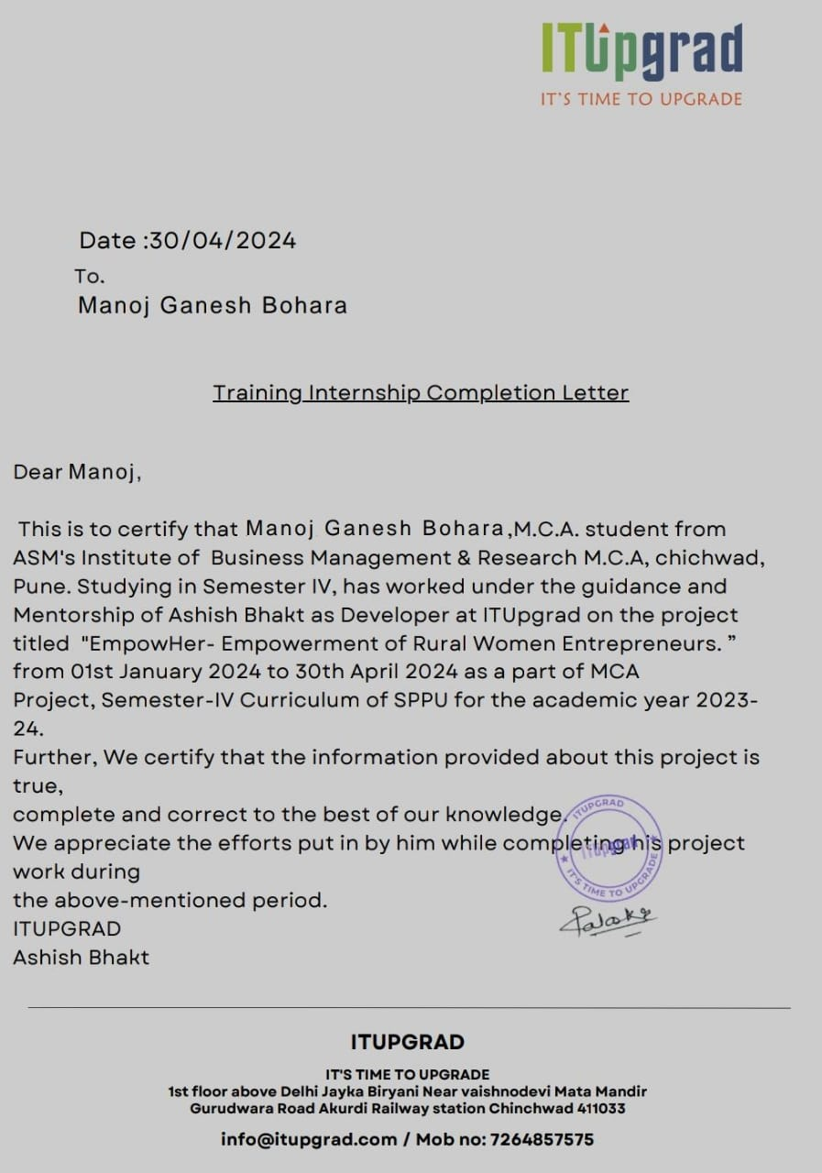

**ACKNOWLEDGEMENT**

It is a pleasure to acknowledge the assistance of several people and institutions in this effort. This project has turned me into a debtor. First and foremost, I feel indebted to my guide **Prof.Vijaya Jadhav** and all the faculty members of Department of MCA, ASM’s IBMR, MCA Institute Chinchwad for their valuable guidance, continuous support and advice and constant encouragement throughout my project work.

I would like to extend my gratitude to honorable **Dr. V. P. Pawar Sir, Director, ASM’s IBMR, MCA Institute, Chinchwad** for being a constant source ofinspiration.

Finally, I would like to extend my thanks to all those who have contributed, directly or indirectly to make this project successful.

**Manoj.G.Bohara (3731)**

**Index**

|  |  |  |
| --- | --- | --- |
| **Chapter** | **Topic** | **Page No.** |
| **1** | **INTRODUCTION** | 1 |
| 1.1 | Company Profile/ Institute Profile | 2 |
| 1.2 | Abstract | 3 |
| 1.3 | Existing System and Need for System | 4 |
| 1.4 | Scope of System | 5 |
| 1.5 | Operating Environment- Hardware and Software | 6 |
| 1.6 | Brief Description of Technology Used | 7-8 |
| **2** | **PROPOSED SYSTEM** | 10 |
| 2.1 | Study of Similar Systems (Literature Survey) | 11 |
| 2.2 | Feasibility Study | 12-13 |
| 2.3 | Objectives of Proposed System | 14 |
| 2.5 | User Requirements | 15 |
| **3** | **ANALYSIS & DESIGN** | 17 |
| 3.1 | System Requirements (Functional and Non-Functional Survey) | 18-26 |
| 3.2 | Data Flow Diagrams (DFD) | 27-30 |
| 3.3 | Entity Relationship Diagram (ERD) | 31 |
| 3.4 | Table Structure | 32-33 |
| 3.5 | Use Case Diagrams | 34 |
| 3.6 | Class Diagram | 35 |
| 3.7 | Activity Diagram | 36-38 |
| 3.8 | Sequence Diagram | 39-40 |
| 3.9 | User Interface Designs | 41-55 |

|  |  |  |
| --- | --- | --- |
| 3.10 | Reports | **56-60** |
| **4** | **CODING** | **62** |
| 4.1 | Algorithms | 63-67 |
| 4.2 | Code Snippet (Sample Code) | 68-90 |
| **5** | **TESTING** | 92 |
| 5.1 | Test Strategy | 93-35 |
| 5.2 | Test Case / Test Script | 96-102 |
| 5.3 | Defect Report / Test Log | 103-105 |
| **6** | **LIMITATIONS OF PROPOSED SYSTEM** | 108 |
| **7** | **PROPOSED ENHANCEMENTS** | 112 |
| **8** | **CONCLUSION** | 116 |
| **9** | **BIBLIOGRAPHY** | 119 |

**CHAPTER 1**

**INTRODUCTION**

**1.1 Company Profile / Institute Profile**

Syntiaro Solutions is a dynamic and innovative IT services company ready to transform the technology landscape. We were founded in 2020 to provide businesses with IT solutions that provide efficiency, growth, and competitiveness in the digital age.

At Syntiaro Solutions, we envision a future where technology is integrated into all aspects of business, production increases and innovation is encouraged. We aim to be the catalyst for this change by providing IT services tailored to our customers' needs. Basic Services.

1. **Software Development:** We focus on creating custom software solutions that fit your unique business needs, ensuring you have the tools to succeed in your rapidly growing digital space.
2. **Web Development:** Our web development services cover everything from corporate websites to powerful e-commerce websites, giving you a strong online presence.
3. **Mobile App Development:** We design and develop user-friendly mobile applications for iOS and Android, leveraging the power of mobile technology to connect with your audience.
4. **Cloud Solutions:** Syntiaro Solutions offers cloud-based services to streamline operations, enhance data security, and enable scalable growth for your business.
5. **IT Consulting and implementation:** Our experienced team provides strategic IT guidance to help you make informed decisions and maximize your technology investments.
6. **Staffing Services:** We provide integrated IT staffing solutions that connect businesses with the best local and international talent, ensuring you have the established team you need to achieve your goals. We invite you to explore our website at www.syntiaro.com to learn more about our services and case studies showcasing our successful projects. Syntiaro Solutions is committed to driving innovation, fostering growth, and empowering your business through technology.

**1.2 Abstract**

The traditional campus recruitment process often faces challenges in terms of efficiency, accessibility, and scalability. In response to these challenges, this project proposes the development of an online campus recruitment platform aimed at streamlining the recruitment process for both employers and students.

The platform will provide a centralized hub where employers can post job openings, schedule interviews, and interact with potential candidates virtually. Similarly, students will have access to a wide range of job opportunities, allowing them to explore career options conveniently from their campus or home.

Key features of the platform include personalized job recommendations based on student profiles, automated scheduling for interviews, and real-time communication between employers and candidates. Additionally, the platform will incorporate tools for resume building, interview preparation, and career guidance to enhance students' chances of securing employment.

Through the implementation of this online campus recruitment platform, we aim to improve the efficiency of the recruitment process, reduce logistical challenges, and bridge the gap between employers and talented students. By leveraging technology, we envision creating a more inclusive and accessible recruitment ecosystem that benefits both students and employers alike.

**1.3 Existing System and Need for System**

* **Existing System:**

The current campus recruitment process predominantly relies on traditional methods such as career fairs, on-campus interviews, and job postings on physical notice boards. Here's an overview of the existing system:

* + **Physical Career Fairs:** Colleges and universities organize periodic career fairs where employers set up booths to interact with students, provide information about job opportunities, and collect resumes. These events typically require significant logistical planning and coordination.
  + **On-Campus Interviews:** Employers visit campuses to conduct interviews with students who have been shortlisted based on their resumes or referrals. These interviews often take place in designated campus locations such as career centres or conference rooms.
  + **Paper-Based Resume Submissions:** Students submit hard copies of their resumes to potential employers either during career fairs or through campus career centres. Employers then manually review these resumes to shortlist candidates for further evaluation.
  + **Limited Reach:** The recruitment process primarily targets students enrolled in participating colleges or universities, limiting the reach of job opportunities to a specific demographic or geographic area.
  + **Manual Coordination:** Coordinating interview schedules, communicating with candidates, and managing paperwork are predominantly manual tasks that can be time-consuming and prone to errors.
  + **Resource Intensive:** Both employers and students invest significant time and resources in participating in on-campus recruitment activities, including travel expenses for employers and attendance fees for career fairs.
  + **Limited Visibility and Accessibility:** Job opportunities and recruitment events may not be accessible to all students, particularly those from remote areas or with limited mobility.

* **Need for the System:**

The need for an online campus recruitment platform arises from several key factors:

* + **Accessibility:** With an online platform, both employers and students gain access to a broader pool of opportunities and talent. Students from remote areas or those unable to attend physical job fairs can participate in recruitment activities from anywhere with an internet connection.
  + **Efficiency:** By digitizing the recruitment process, tasks such as job posting, candidate screening, and interview scheduling can be automated, reducing manual effort and streamlining workflows for both employers and students**.**
  + **Scalability:** An online platform enables scalability, allowing for the efficient management of large volumes of job postings, applications, and candidate interactions. This scalability is crucial for accommodating the diverse needs of both small and large-scale recruitment efforts.
  + **Enhanced Communication:** Real-time communication tools integrated into the platform facilitate seamless interaction between employers and candidates, enabling timely feedback, clarifications, and updates throughout the recruitment process.
  + **Data-driven Insights:** The system can gather and analyse data on recruitment trends, candidate preferences, and hiring outcomes, empowering stakeholders to make informed decisions and optimize their recruitment strategies over time.

Overall, the need for an online campus recruitment system is driven by the desire to overcome the limitations of the existing manual processes, improve accessibility and efficiency, and better meet the evolving needs of employers and students in the digital age.

**1.4 Scope of System**

* **User Management:**
  + Registration and authentication mechanisms for students, employers, and administrators.
  + Profile management functionalities allowing users to update their information, preferences, and resumes.
* **Job Posting and Management:**
  + Employers can post job vacancies, specifying details such as job description, requirements, and application deadlines.
  + Ability for employers to manage and edit job postings, including marking positions as filled or expired.
* **Job Search and Recommendation:**
  + Search functionality enabling students to find job opportunities based on criteria such as location, industry, and job type.
  + Recommendation system suggesting relevant job postings to students based on their profiles and preferences.
* **Application and Resume Submission:**
  + Students can apply for jobs directly through the platform by submitting their resumes and cover letters.
  + Employers can review and manage incoming applications, shortlist candidates, and communicate with applicants.
* **Interview Scheduling and Management:**
  + Integration of scheduling tools allowing employers to propose interview times and candidates to accept or suggest alternative slots.
  + Calendar integration to avoid scheduling conflicts and ensure smooth coordination between employers and candidates.
* **Communication and Messaging:**
  + Real-time messaging features enabling communication between employers and candidates for interview arrangements, feedback exchange, and clarifications.
  + Announcement system for administrators to disseminate important information to users.
* **Feedback and Rating System:**
  + Mechanism for employers to provide feedback on candidates after interviews, assisting in the selection process and improving candidate experience.
  + Rating system allowing both employers and students to rate their experience with each other, fostering accountability and transparency.
* **Analytics and Reporting:**
  + Dashboard providing administrators with insights into recruitment activities, including job posting metrics, application statistics, and hiring trends.
  + Reporting functionalities enabling stakeholders to generate custom reports on various aspects of the recruitment process.
* **Career Resources and Guidance:**
  + Integration of resources such as resume templates, interview tips, and career advice to support students in their job search and professional development.
  + Collaboration with career counsellors or advisors to offer personalized guidance and assistance to students.
* **Accessibility and Scalability:**
  + Responsive design ensuring accessibility across different devices and screen sizes, including desktops, laptops, tablets, and smartphones.
  + Scalable architecture capable of handling increased user traffic and expanding functionalities to accommodate future growth and enhancements.

The scope outlined above encompasses the core features and functionalities of the online campus recruitment system, aiming to streamline the recruitment process, enhance user experience, and facilitate meaningful connections between employers and students**.**

**1.5 Operating Environment- Hardware and Software**

* **Hardware:**
* Processor Intel Core i3 or Higher/AMD Processors.
* RAM 4GB or Higher
* Cache memory 512KB or higher
* Operating System Windows 8 or higher
* Hard Disk 160 GB
* Keyboard 108 Keys
* Mouse Optical mouse
* **Software:**
* Frontend/language HTML, CSS, JS
* Backend/database PHP, MySQL
* Additional tools VS CODE
* Operating System Windows 8 or higher

**1.6 Brief Description of Technology Used**

The technology stack used for the "Online Campus Recruitment" project involves a combination of frontend and backend technologies, along with a relational database for data management. Here's a brief description of each component:-

* **Frontend Technologies:**
* **HTML (Hyper Text Markup Language):**

HTML is used to create the structure and content of web pages. It defines the layout and elements of the user interface, including text, images, forms, and links.

* **CSS (Cascading Style Sheets):**

CSS is employed to style the HTML elements, providing visual enhancements such as colors, fonts, layouts, and responsive design. It ensures a consistent and appealing presentation of the web application.

* **JavaScript (JS):**

JavaScript is used for implementing interactive and dynamic features on the frontend. It enhances user experience by enabling functionalities such as form validation, animations, asynchronous data loading, and event handling.

* **Backend Technology:**
* **PHP:**

PHP serves as the primary backend programming language for implementing the business logic and server-side functionalities of the web application. PHP is known for its simplicity, flexibility, and wide adoption, making it suitable for rapid development and integration with various web technologies. Its extensive library support and strong community contribute to handling complex operations and business processes efficiently.

* **Database Technology:**
* **MySQL:**

MySQL is utilized as the relational database management system (RDBMS) to store and manage the project's data. It provides a structured approach to organizing data into tables, ensuring data integrity, and supporting efficient querying and data retrieval operations.

* **Integration and Communication:**

**RESTful APIs:**

RESTful APIs are used to establish communication between the frontend and backend components of the application. They facilitate data exchange and interaction by defining standardized endpoints for accessing resources and performing CRUD (Create, Read, Update, Delete) operations.

* **Deployment and Hosting:**

**Deployment Platforms:**

The web application may be deployed on cloud platforms such as AWS (Amazon Web Services), Google Cloud Platform, or Microsoft Azure for scalability, reliability, and global accessibility.

* **Security Measures:**

**Data Encryption:**

Encryption techniques (e.g., HTTPS protocol) are implemented to ensure secure transmission of sensitive data between clients and servers.

* **Authentication and Authorization:**

User authentication and authorization mechanisms (e.g., JWT tokens, OAuth) are integrated to control access to application resources and protect against unauthorized actions.

**CHAPTER 2**

**PROPOSED SYSTEM**

**2.1 Study of Similar Systems (Literature Survey)**

|  |  |  |  |
| --- | --- | --- | --- |
| **Sr. No** | **Name** | **No. of Modules** | **Remarks** |
| 1. | Naukri.com Campus Hiring Solutions | 6 | Naukri.com offers comprehensive campus hiring solutions, connecting employers with fresh graduates. It provides tools for managing recruitment processes, from job postings to candidate selection, enhancing the efficiency of campus recruitment. |
| 2. | Handshake | 6 | Handshake is a leading platform for college career services, connecting students and recent graduates with employers. It offers job listings, virtual career fairs, and networking opportunities, facilitating effective campus recruitment. |
| 3. | LinkedIn Talent Solutions | 6 | LinkedIn Talent Solutions provides tools for employers to recruit from campuses globally. It offers advanced search capabilities, candidate recommendations, and employer branding options, supporting efficient and targeted campus recruitment efforts. |
| 4. | CollegeRecruiter.com | 6 | CollegeRecruiter.com specializes in connecting college students and recent graduates with entry-level jobs and internships. It offers job postings, employer profiles, and career resources, helping streamline the campus recruitment process. |
| 5. | Grad Connection | 6 | Grad Connection provides a platform for employers to connect with students and graduates across the Asia-Pacific region. It offers job postings, employer branding, and campus event management, supporting comprehensive campus recruitment strategies. |

**2.2 Feasibility Study**

**1. Economic Feasibility:**

* **Cost-Benefit Analysis:** Evaluate the projected costs of implementing the Online Campus Recruitment system against the expected benefits, such as improved recruitment efficiency, reduced hiring costs, and better talent acquisition. Assess the economic impact on the organization, including potential savings and increased productivity.
* **Revenue Generation:** Identify potential revenue streams or funding sources to sustain the Online Campus Recruitment system in the long run. Explore options such as charging fees for premium job postings, offering subscription-based services to employers, or securing sponsorships and grants from relevant organizations.

**2. Technical Feasibility:**

* **Technology Infrastructure:** Assess the existing technology infrastructure within the organization or educational institution to determine if it can support the implementation of the Online Campus Recruitment system. Evaluate factors such as network capabilities, hardware compatibility, and data security requirements.
* **Training Tools:** Ensure that the technical tools and platforms used for the Online Campus Recruitment system are user-friendly and accessible to administrators. Provide training and support resources to familiarize administrators with the system, considering varying levels of technical expertise.

**3. Operational Feasibility:**

* **Training Programs:** Evaluate the feasibility of implementing training programs for administrators responsible for managing the Online Campus Recruitment system. Consider logistical challenges, resource availability, and the need for ongoing support and professional development.
* **Support Network:** Assess the feasibility of establishing a support network for administrators and users of the Online Campus Recruitment system. Consider mechanisms for providing technical assistance, troubleshooting issues, and facilitating communication and collaboration among stakeholders.

**4. Schedule Feasibility:**

* **Project Timeline:** Develop a realistic timeline for the implementation of the Online Campus Recruitment system, considering key milestones such as system design, development, testing, and deployment. Allocate resources and manpower effectively to ensure timely completion of each phase.
* **Critical Path Analysis:** Identify critical tasks and potential bottlenecks that could impact the schedule of the Online Campus Recruitment system implementation. Mitigate risks by prioritizing tasks, allocating additional resources where necessary, and implementing contingency plans.

**5. Legal and Regulatory Feasibility:**

* **Compliance:** Ensure that the Online Campus Recruitment system complies with relevant laws and regulations governing recruitment, data privacy, and equal opportunity employment. Conduct a thorough review of legal requirements and incorporate necessary safeguards into the system.
* **Documentation:** Verify the legal documentation required for the operation of the Online Campus Recruitment system, such as user agreements, privacy policies, and terms of service. Ensure transparency and accountability in all aspects of system operation.

**6. Social and Cultural Feasibility:**

* **Cultural Sensitivity:** Assess the social and cultural context of the educational institution and its stakeholders to ensure that the Online Campus Recruitment system respects diversity and inclusivity. Consider cultural norms, language preferences, and accessibility requirements in system design and implementation.
* **Community Engagement:** Evaluate strategies for engaging students, faculty, and employers in the use of the Online Campus Recruitment system. Foster a sense of ownership and participation by soliciting feedback, addressing concerns, and promoting the benefits of the system to all stakeholders.

**2.3 Objectives of Proposed System**

The objectives of a proposed system for online campus recruitment can be outlined as follows:

* + - **Streamlined Recruitment Process:** The primary objective of the proposed online campus recruitment system is to streamline the recruitment process for both employers and students. By digitizing and automating various recruitment tasks, such as job posting, resume submission, and interview scheduling, the system aims to reduce manual effort and improve efficiency.
    - **Increased Accessibility:** The system seeks to enhance accessibility to job opportunities for students by providing a centralized online platform where they can explore a wide range of job openings from various employers. This accessibility ensures that all students, regardless of their location or schedule, have equal access to recruitment opportunities.
    - **Improved Interaction:** The proposed system aims to facilitate real-time interaction between employers and candidates through features such as instant messaging, video interviews, and virtual career fairs. By enabling seamless communication, the system enhances the overall recruitment experience for both parties and fosters better engagement throughout the hiring process.
    - **Enhanced Candidate Experience:** Another objective of the system is to improve the candidate experience by providing tools and resources for resume building, interview preparation, and career guidance. These features empower students to present themselves effectively to potential employers and increase their chances of securing employment.
    - **Data-driven Decision Making:** The system will gather and analyze data on recruitment activities, candidate preferences, and hiring outcomes to provide valuable insights to stakeholders. By leveraging data analytics, employers and administrators can make informed decisions to optimize their recruitment strategies and improve overall outcomes.
    - **Scalability and Adaptability:** The proposed system will be designed to be scalable and adaptable to accommodate the diverse needs of both small and large-scale recruitment efforts. This scalability ensures that the system can grow and evolve over time to meet changing requirements and support increased user demand.

Overall, the objectives of the proposed online campus recruitment system are to enhance the efficiency, accessibility, interaction, candidate experience, data-driven decision making, scalability, and adaptability of the recruitment process, ultimately benefiting both employers and students.

**2.4 User Requirements**

* **User Interface Requirements:**

1. The user interface should be web-based and compatible with popular web browsers such as Internet Explorer, Google Chrome, and Mozilla Firefox.
2. The interface should be designed with a focus on usability and ease of navigation for users with basic computer skills.
3. Appropriate input validation and error handling mechanisms should be implemented to ensure data integrity and user-friendly error messages.

* **Design Constraints:**

1. No specific memory requirements are mentioned.
2. The system should be accessible through web browsers on computers with internet connectivity.
3. Users are expected to have basic computer skills to interact with the product.

* **Performance Requirements:**

1. The system should be designed to run on good working computers with the required software and hardware specifications.
2. The product should be hosted on a web server and accessed through the internet.
3. The initial load time may vary depending on the internet connection strength.

* **Data Storage and Security Requirements:**

1. User passwords should never be displayed in the web browser for security purposes.
2. Credit card numbers should be masked or obfuscated when retrieved from the database and displayed in the web browser.
3. Access to the back-end servers should be restricted to authenticated administrators only.
4. The back-end databases should have login credentials for secure access.

Online User Documentation and Help System Requirements:

1. An online user documentation and help system should be provided to guide Students in using online campus recruitment for student employment.
2. The help system should include features like links, search fields, and clear instructions for various tasks and functionalities.
3. The user documentation should be easily accessible and well-organized for seamless navigation and reference.

**CHAPTER 3**

**ANALYSIS & DESIGN**

**3.1 System Requirements (Functional and Non-Functional Survey)**

* **Functional Requirements:**

This section outlines the use cases for each of the active users separately. The admin, student, and company each have specific functionalities they interact with in the system.

**1.1 Admin Use Cases:**

Use case: **Manage Users:**

Manage Users

**Admin**

**Brief Description:**

The admin manages user accounts, including adding, editing, and deleting user profiles for all modules.

**Initial Step-By-Step Description:**

Before this use case can be initiated, the admin has already accessed the admin dashboard.

1. The admin navigates to the user management section.
2. The system presents options to add, edit, or delete user profiles.
3. The admin selects the desired action (add, edit, delete).
4. If adding or editing, the admin fills in or modifies user information.
5. The admin submits the changes, and the system updates user profiles accordingly.

Use case: **Manage Services:**

Manage

Services

**Admin**

**Brief Description:**

The admin manages service categories, including adding, editing, and deleting categories.

**Initial Step-By-Step Description:**

Before this use case can be initiated, the admin has already accessed the admin dashboard.

1. The admin navigates to the service category management section.
2. The system presents options to add, edit, or delete categories.
3. The admin selects the desired action (add, edit, delete).
4. If adding or editing, the admin fills in or modifies category information.
5. The admin submits the changes, and the system updates categories accordingly.

**1.2 Student Use Cases:**

Use case: Manage Profile

Manage Profile

**Student**

**Brief Description:**

The student manages their profile, including adding, editing, and updating personal and academic information.

**Initial Step-By-Step Description:**  
Before this use case can be initiated, the student has already logged in to their dashboard.

1. The student navigates to the "Profile" section.
2. The system presents options to view, add, or edit profile information.
3. The student selects the desired action (add or edit).
4. The student fills in or modifies their personal and academic information.
5. The student submits the changes, and the system updates the profile accordingly.

Use case: **Search and Apply for Jobs:**

Search & Apply for Jobs

**Student**

**Brief Description:**

**Brief Description:**  
The student searches for job opportunities and applies to suitable positions.

**Initial Step-By-Step Description:**  
Before this use case can be initiated, the student has already logged in to their dashboard.

1. The student navigates to the "Job Search" section.
2. The system presents a search interface with filters for job type, location, company, etc.
3. The student enters search criteria and initiates the search.
4. The system displays a list of job opportunities matching the search criteria.
5. The student views job details and selects positions to apply for.
6. The student completes and submits the application for the selected jobs.
7. The system confirms the application submission and updates the student's application status.

**1.3 Company Use Cases:**

Use case: **Manage Company Profile:**

Manage Company Profile

**Company**

**Brief Description**:

The employer manages their company profile, including adding, editing, and updating company information.

**Initial Step-By-Step Description:**  
Before this use case can be initiated, the employer has already logged in to their dashboard.

1. The employer navigates to the "Company Profile" section.
2. The system presents options to view, add, or edit company information.
3. The employer selects the desired action (add or edit).
4. The employer fills in or modifies the company details, such as name, description, location, and contact information.
5. The employer submits the changes, and the system updates the company profile accordingly.

Use case: **Post Job Opportunity:**

Post Job Opportunity

**Company**

**Brief Description:**

The employer posts a new job opportunity on the platform.

**Initial Step-By-Step Description:**  
Before this use case can be initiated, the employer has already logged in to their dashboard.

1. The employer navigates to the "Post Job" section.
2. The system presents a form for the employer to fill in job details.
3. The employer fills in the required information such as job title, description, requirements, salary, etc.
4. The employer submits the form, and the system adds the job opportunity to the platform.

Use case: **Manage Applications:**

Manage Applications

**Company**

**Brief Description:**  
 The employer manages applications received for their posted job opportunities.

**Initial Step-By-Step Description:**  
Before this use case can be initiated, the employer has already logged in to their dashboard.

1. The employer navigates to the "Manage Applications" section.
2. The system displays a list of applications received for the job opportunities posted by the employer.
3. The employer can view application details, filter applications based on various criteria, and shortlist candidates.
4. The employer updates the status of applications (e.g., shortlisted, rejected, interview scheduled).
5. The employer submits any changes, and the system updates the application status accordingly.

* **Non-Functional Requirements:**

1. **Server and Network Requirements:**

* The system will be hosted on a server with high-speed internet connectivity to ensure reliable and efficient access for all users (Student, Company and Admins).
* The server hardware specifications will be determined based on the anticipated user load and performance requirements.

1. **Web Application Platform:**

* The web application will be developed using a robust web server platform like Apache Tomcat or a similar solution for handling web requests and database connections.

1. **Client Hardware Requirements:**

* The system will be accessible from various client devices (desktops, laptops, tablets, smartphones) with internet connectivity.
* The performance and user experience may vary depending on the client hardware specifications and internet connection speed.

1. **Admin Application Requirements:**

* The admin application for managing the system will be developed using a platform compatible with the Windows operating system.
* The admin application will utilize a local database, such as xampp which is already installed on the Admin's computer.

1. **Scalability and Extensibility:**

* The system should be designed to handle an increasing number of users, products/services, and transactions over time.
* The architecture should be modular and extensible to accommodate future enhancements and additional features.

1. **Security and Data Protection:**

* Appropriate security measures, such as encryption, authentication, and authorization, should be implemented to protect user data and transactions.
* Compliance with relevant data protection regulations and privacy laws should be ensured.

1. **Usability and Accessibility:**

* The user interfaces for Student and Company should be intuitive, user-friendly, and accessible to users with varying levels of technical expertise.
* Adherence to web accessibility standards should be considered to ensure inclusivity.

1. **Maintainability and Documentation:**

* The codebase should be well-organized, documented, and follow best coding practices to facilitate future maintenance and updates.
* Comprehensive documentation should be provided for system administrators, developers, and end-users.

1. **Localization and Internationalization:**

* The system should support multiple languages and locales to cater to a diverse user base, if required.

1. **Performance and Response Time:**

* The system should provide acceptable response times for various user interactions, such as searching, browsing, and transactions.
* Performance optimization techniques should be employed to ensure a smooth user experience.

**3.2 Data Flow Diagrams (DFD)**

* **DFD ZERO Level :**

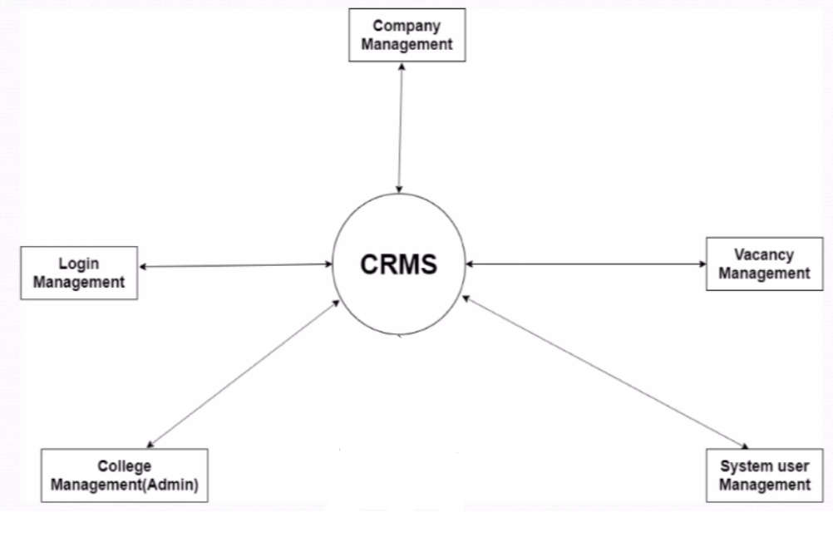

* **DFD FIRST Level:**

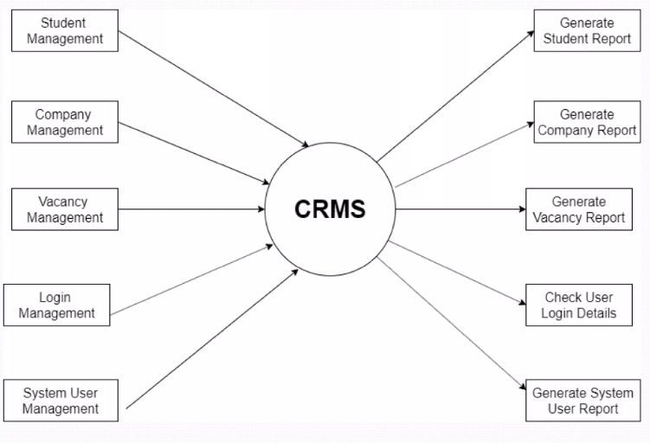

* **DFD SECOND Level:**

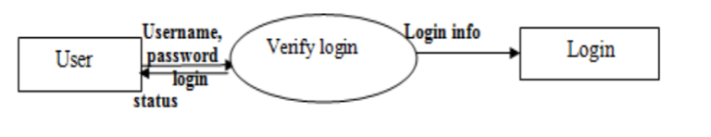

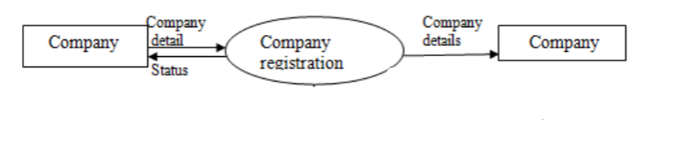

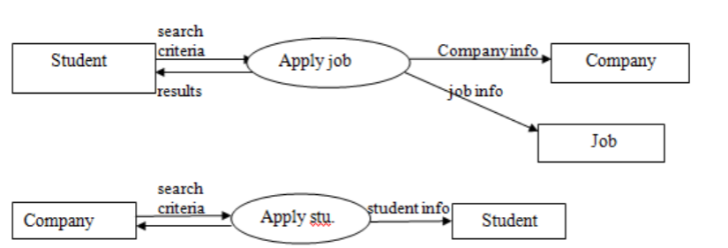

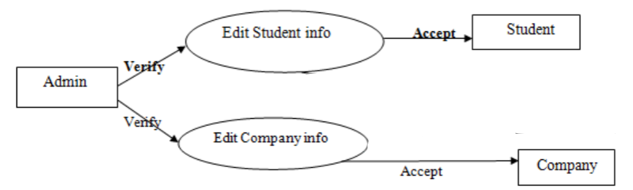

**3.3 Entity Relationship Diagram (ERD)**

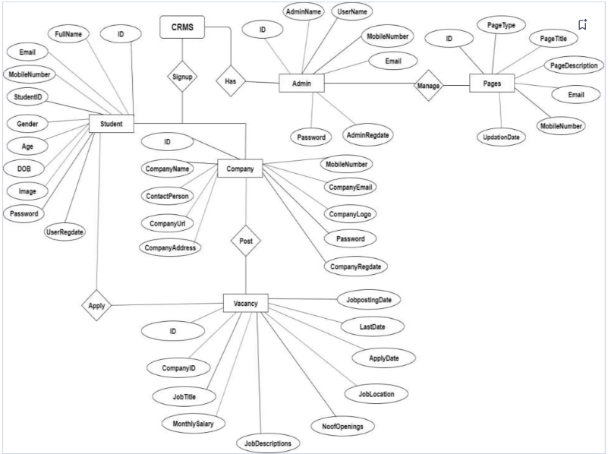

**3.4 Table Structure**

**1. Tablename: Admin**

|  |  |  |  |  |
| --- | --- | --- | --- | --- |
| **SR.NO** | **Attribute** | **Data Type** | **Description** | **Constraints** |
|  | a_id | int | Administration ID | Primary Key |
|  | a_name | String | Admin Name |  |
|  | a_email | String | Email ID |  |
|  | A_pass | String | Password |  |

**2. Tablename: Student**

|  |  |  |  |  |
| --- | --- | --- | --- | --- |
| **SR.NO** | **Attribute** | **Data Type** | **Description** | **Constraints** |
|  | c_id | int | Student ID | Primary Key |
|  | c_name | String | Student Name |  |
|  | c_pass | String | Password |  |
|  | c_mobno | long int | Mobile Number |  |
|  | c_email | String | Email ID |  |

***3*. Tablename: Company**

|  |  |  |  |  |
| --- | --- | --- | --- | --- |
| **SR.NO** | **Attribute** | **Data Type** | **Description** | **Constraints** |
|  | i_id | int | Company ID | Primary Key |
|  | i_name | String | Company Name |  |
|  | i_pass | String | Password |  |
|  | i_mobno | long int | Mobile Number |  |
|  | i_email | String | Email ID |  |

***4*. Tablename: Entrepreneur**

|  |  |  |  |  |
| --- | --- | --- | --- | --- |
| **SR.NO** | **Attribute** | **Data Type** | **Description** | **Constraints** |
|  | e_id | int | Entrepreneurs ID | Primary Key |
|  | e_name | String | Entrepreneurs Name |  |
|  | e_pass | String | Password |  |
|  | e_mobno | long int | Mobile Number |  |
|  | e_email | String | Email ID |  |

***5*. Tablename: Shop**

|  |  |  |  |  |
| --- | --- | --- | --- | --- |
| **SR.NO** | **Attribute** | **Data Type** | **Description** | **Constraints** |
|  | s_id | int | Shop ID | Primary Key |
|  | s_name | String | Shop Name |  |
|  | s_address | String | Address |  |
|  | s_type | String | Shop Type |  |
|  | s_info | String | Shop Information |  |

***6*. Tablename: Product**

|  |  |  |  |  |
| --- | --- | --- | --- | --- |
| **SR.NO** | **Attribute** | **Data Type** | **Description** | **Constraints** |
|  | p_id | int | Product ID | Primary Key |
|  | c_id | int | Student ID | Foreign Key |
|  | p_name | String | Product Name |  |
|  | p_category | String | Product Category |  |
|  | p_price | String | Product Price |  |
|  | p_info | String | Product Information |  |

***7*. Tablename: Transaction**

|  |  |  |  |  |
| --- | --- | --- | --- | --- |
| **SR.NO** | **Attribute** | **Data Type** | **Description** | **Constraints** |
|  | t_id | int | Transaction ID | Primary Key |
|  | t_date | Date | Transaction Date |  |
|  | t_time | time | Transaction Time |  |

* 1. **Use Case Diagrams**

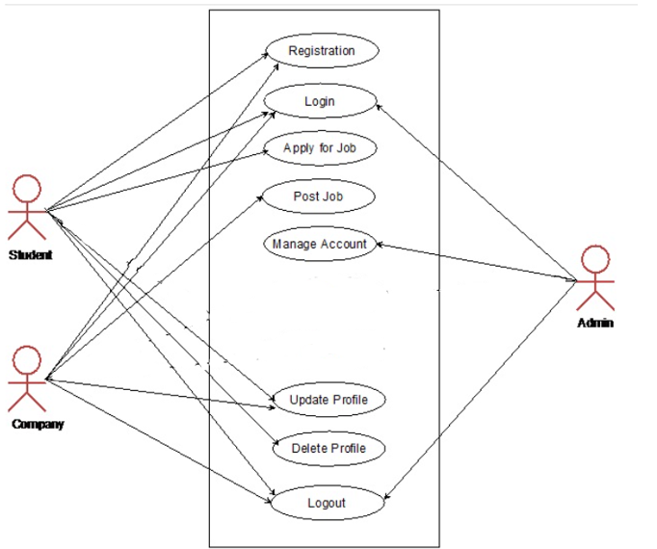

* 1. **Class Diagram**

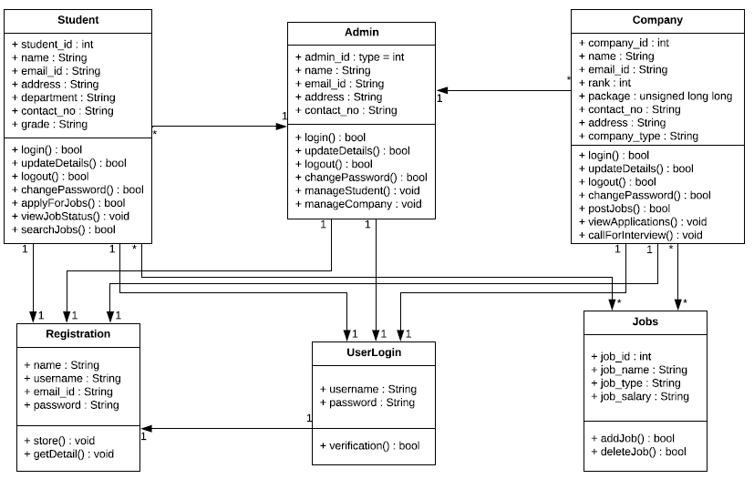

**3.7 Activity Diagram**

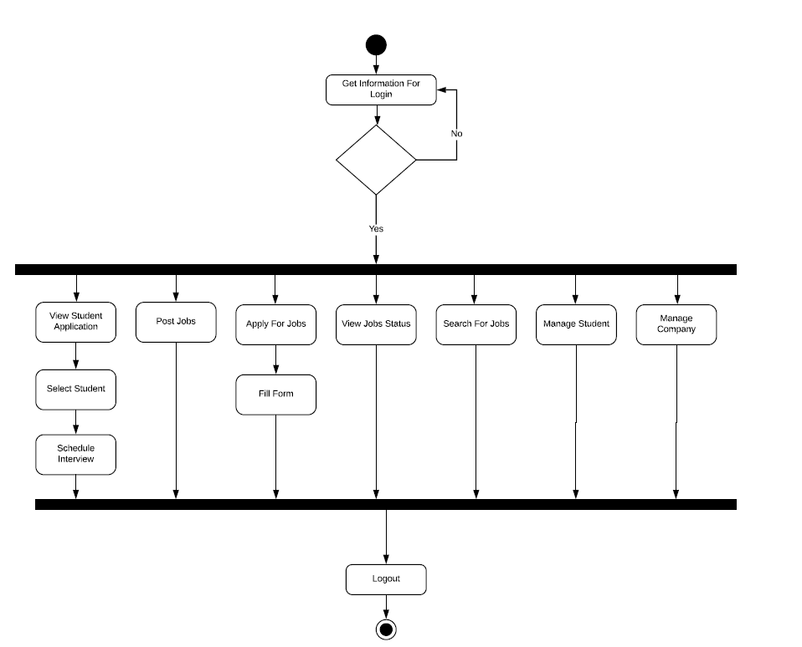

**3.8 Sequence Diagram**

* **Sequence Diagram Company**

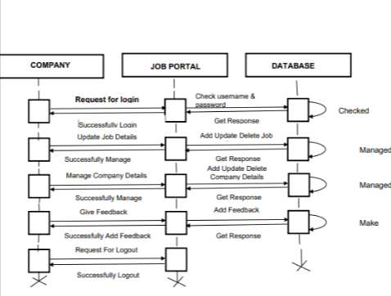

* **Sequence Diagram Student**

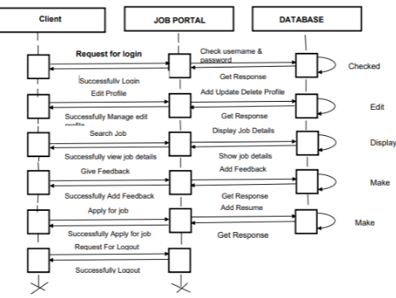

* **Sequence Diagram Admin**

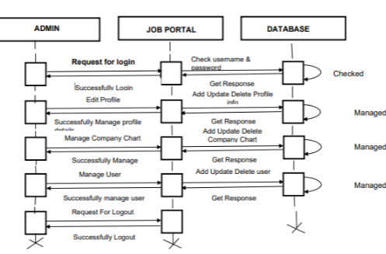

* + 1. **User Interface Designs**

**Dashboard Page**



**Login Page**

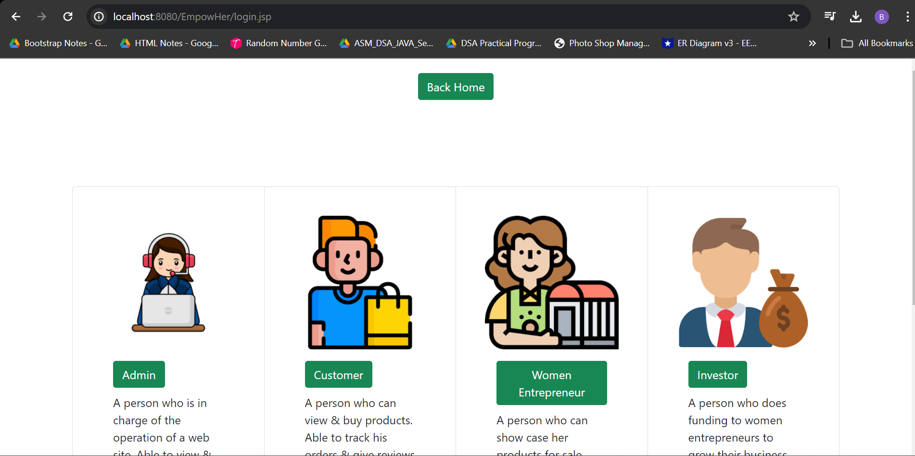

**Admin Login Page**

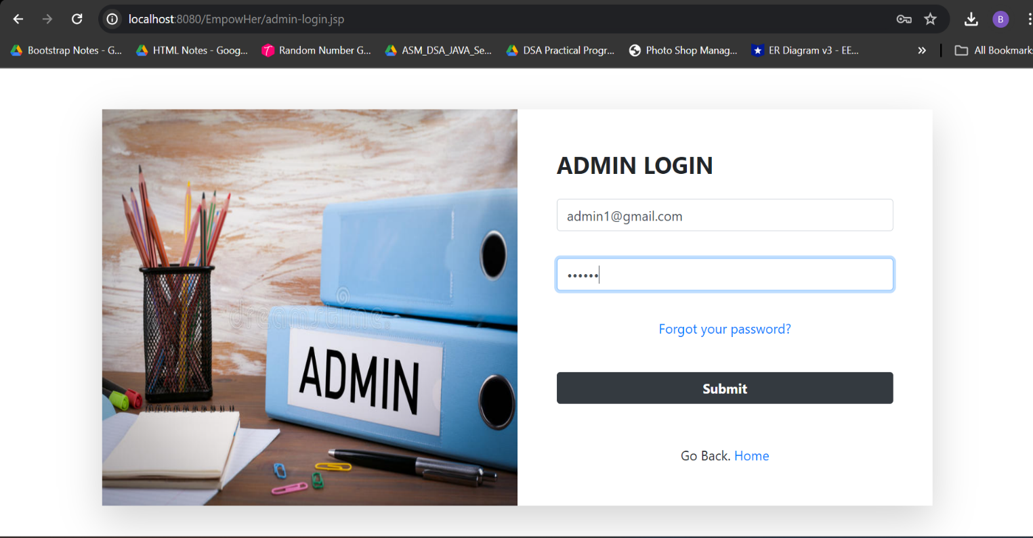

**Admin Login Failed**

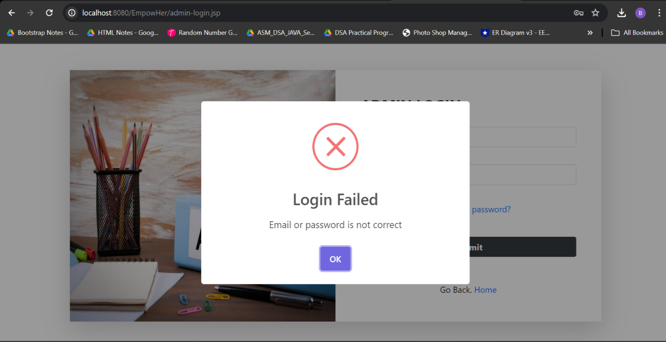

**Admin Login Successful**

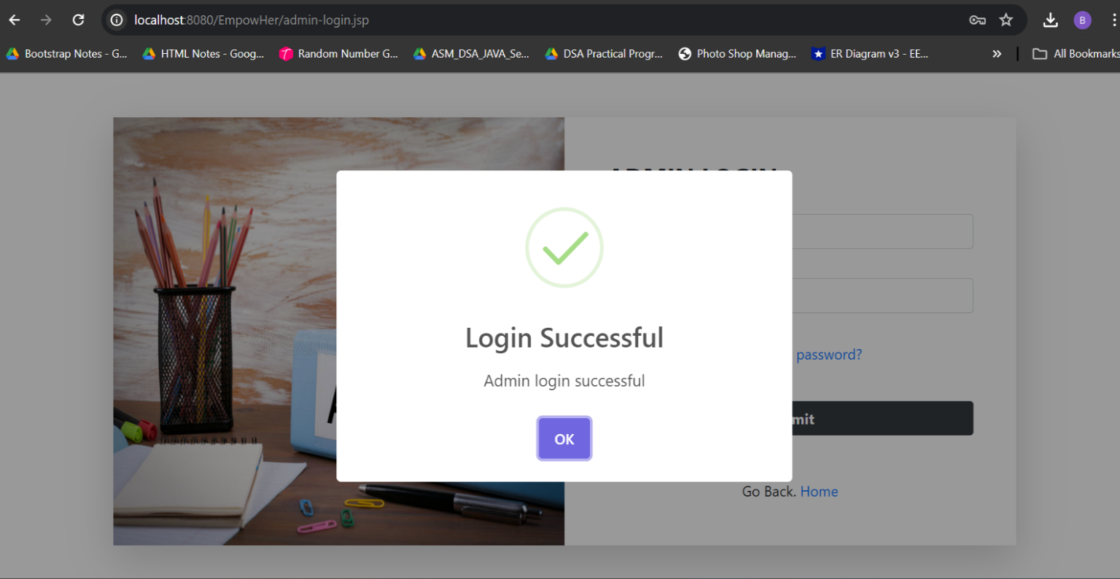

**Admin Dashboard**

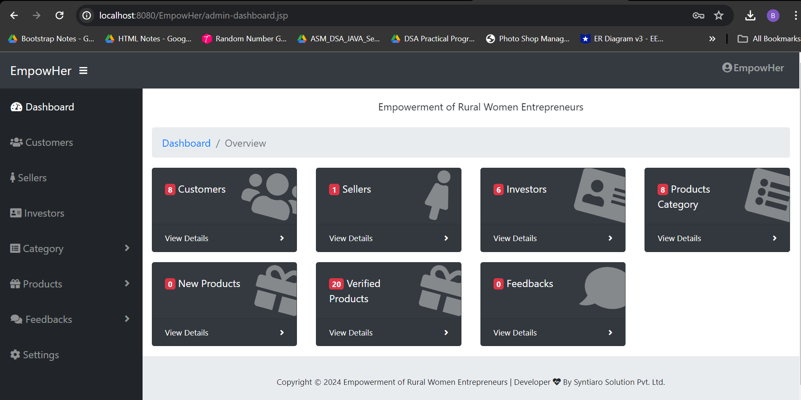

**Admin View Student Details**

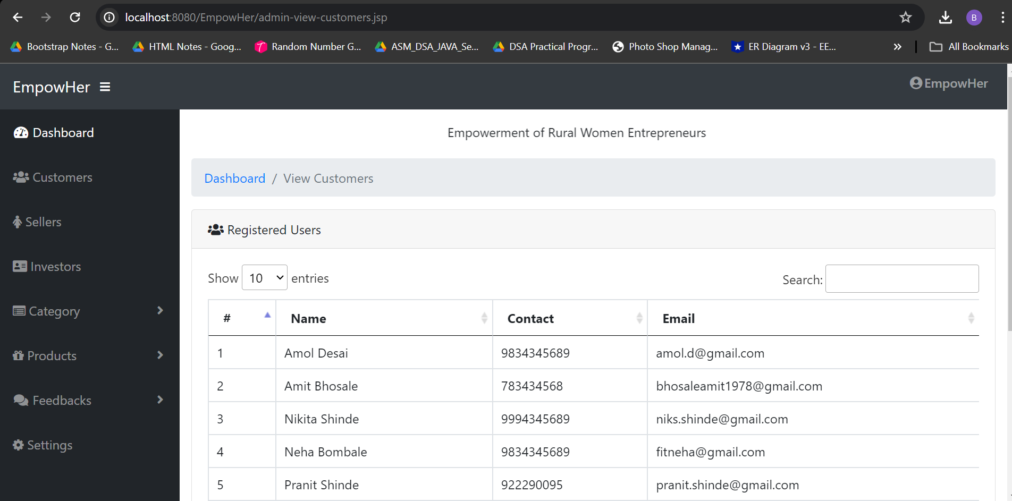

**Admin View Entrepreneurs**

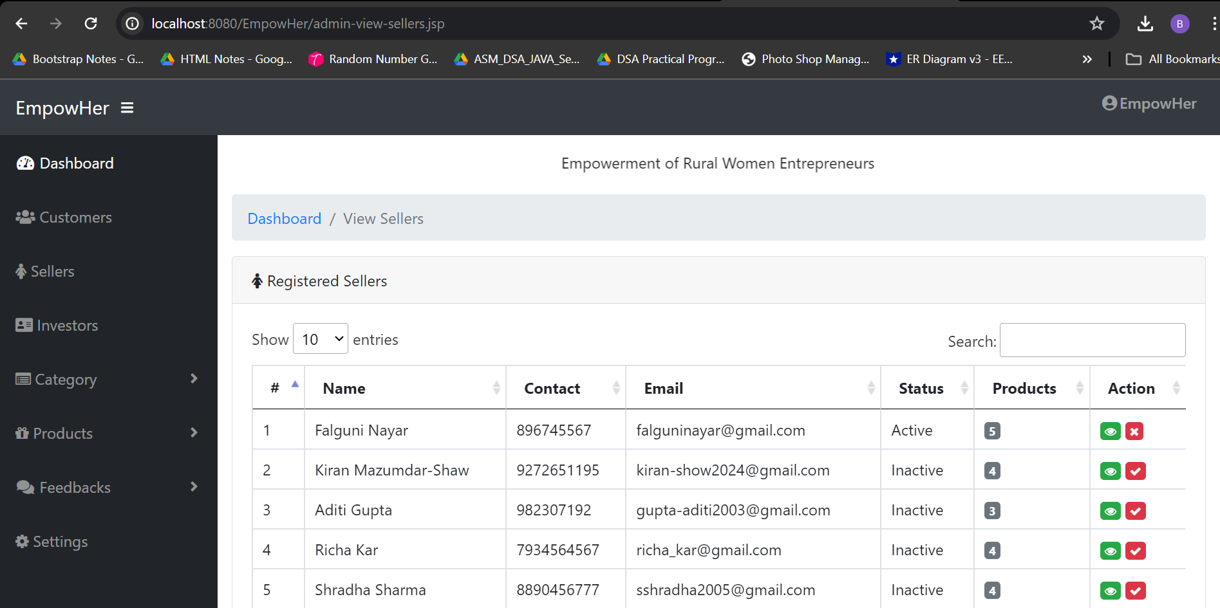

**Admin View Companys**

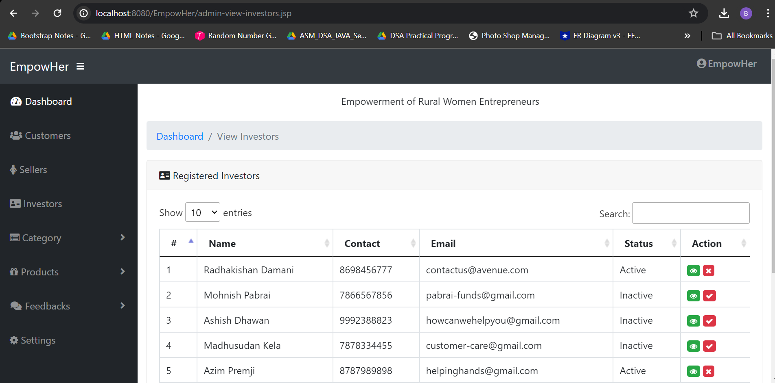

**Admin Logout**

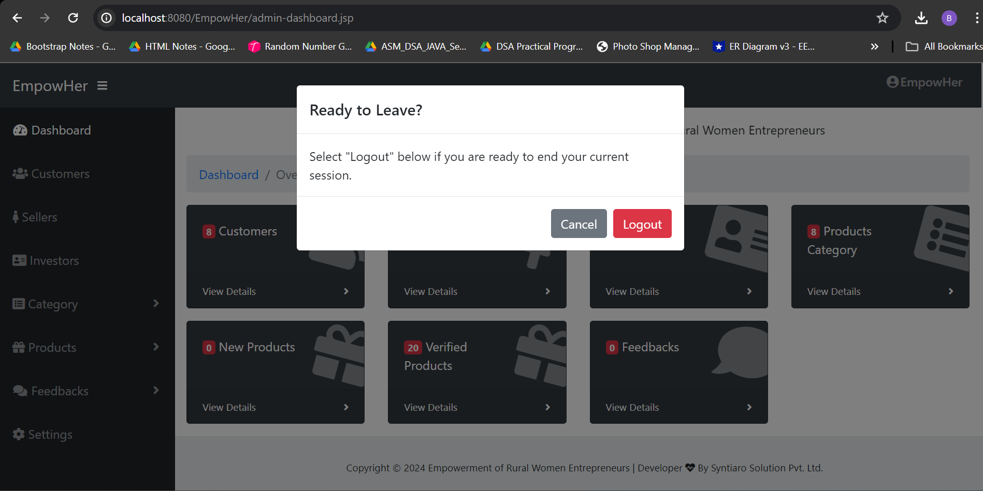

**Student Login**

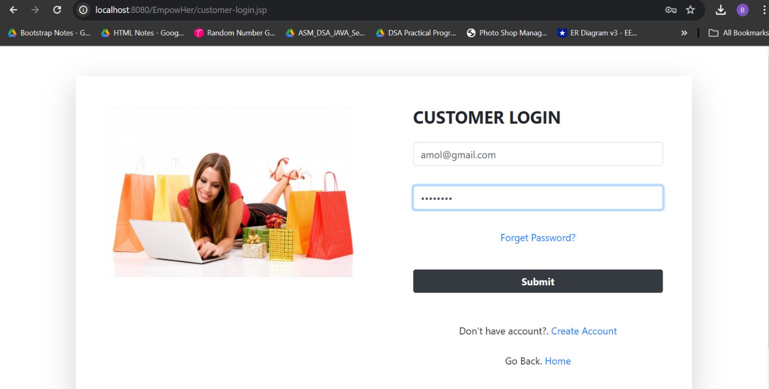

**Student Login Failed**

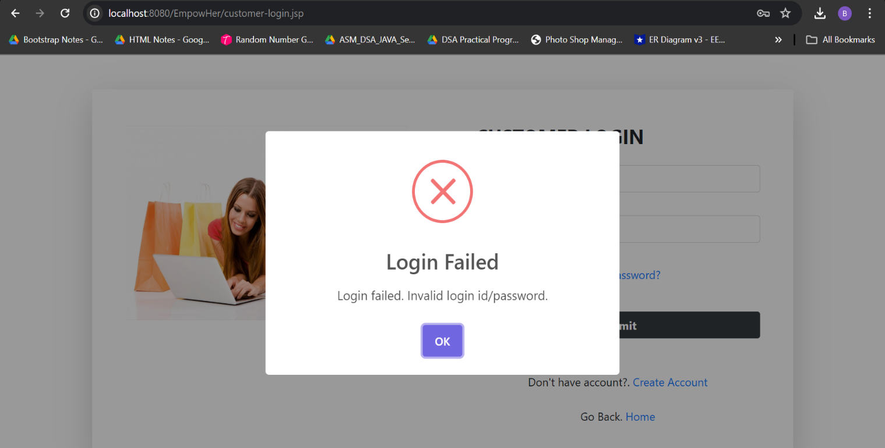

**Student Login Successful**

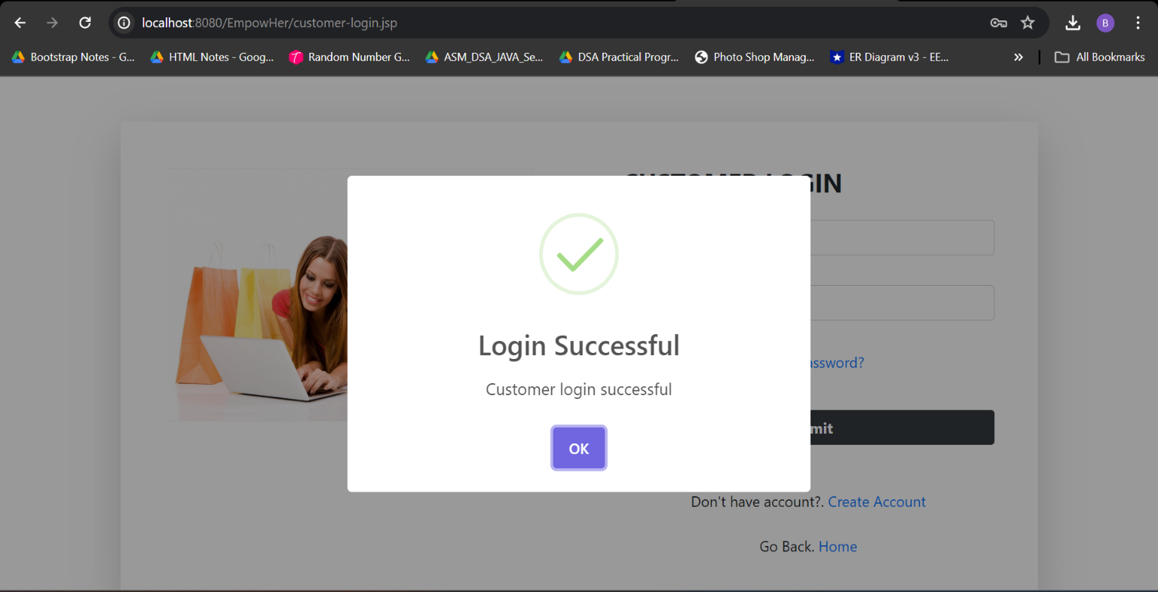

**Student Dashboard**

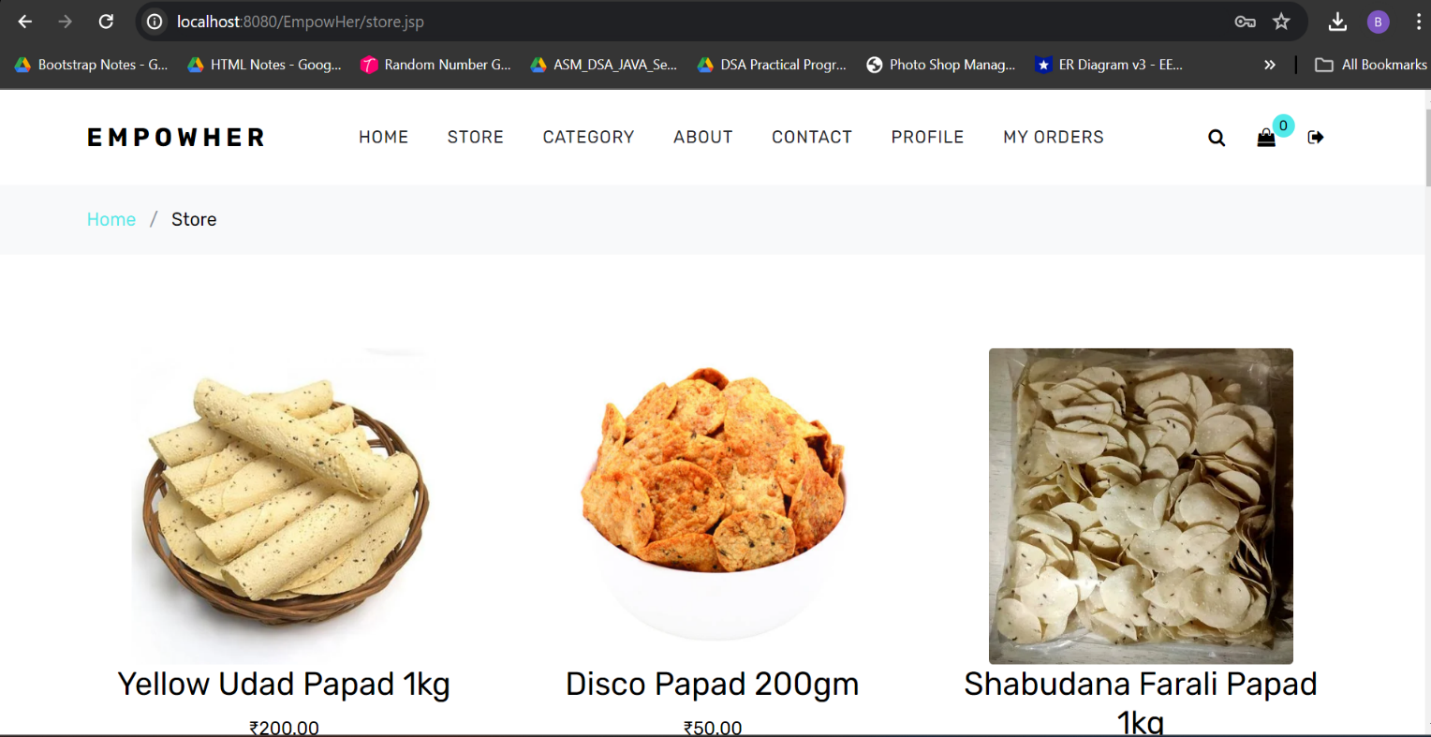

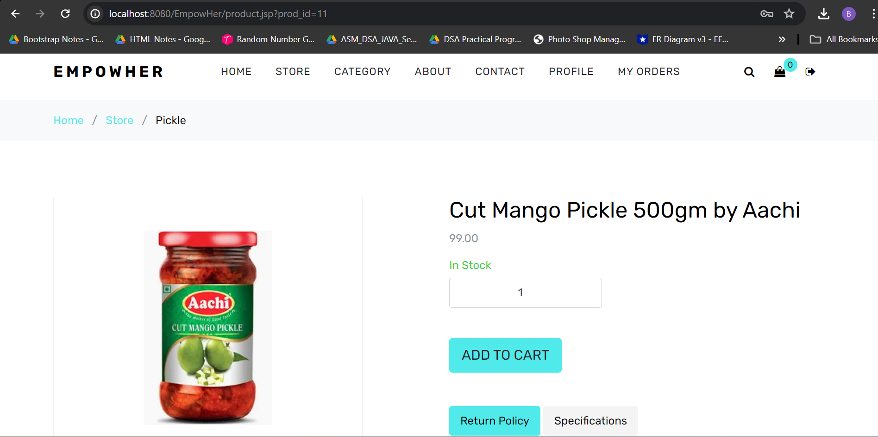

**Student Shopping Cart**

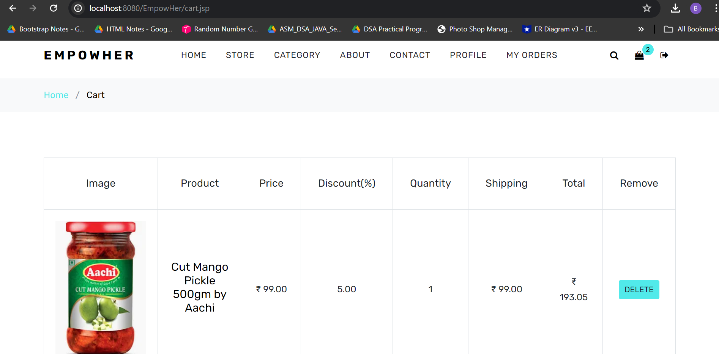

**Student Profile**

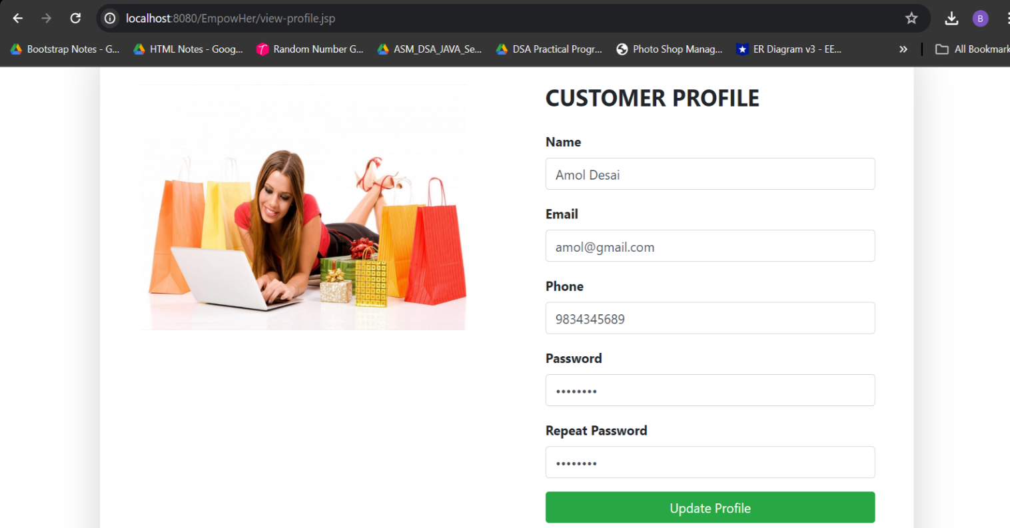

**Student Checkout Page**

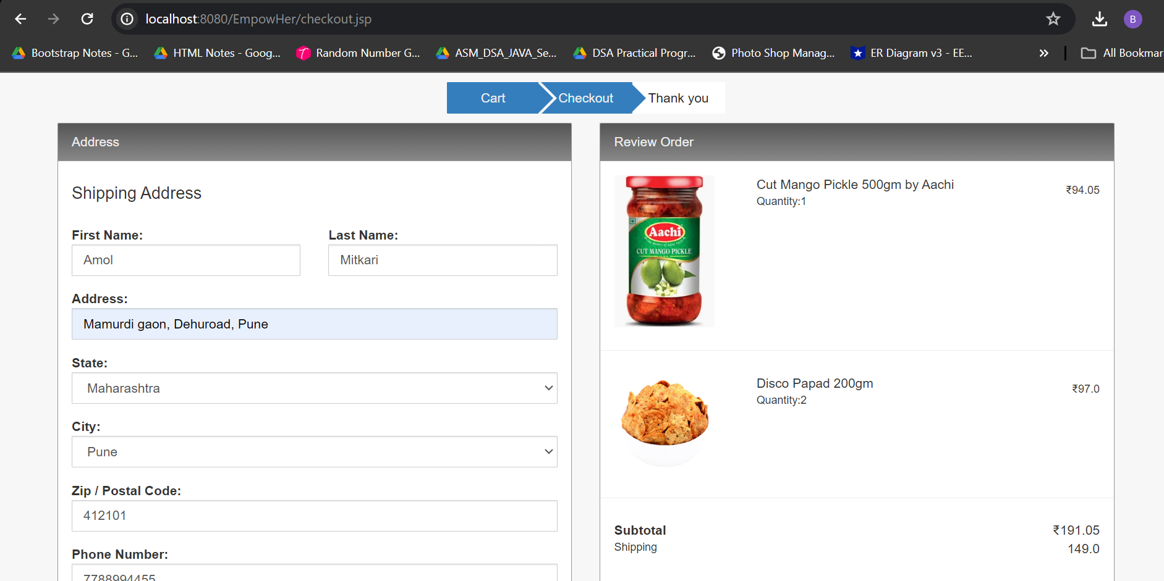

**Proceed To Payment Page**

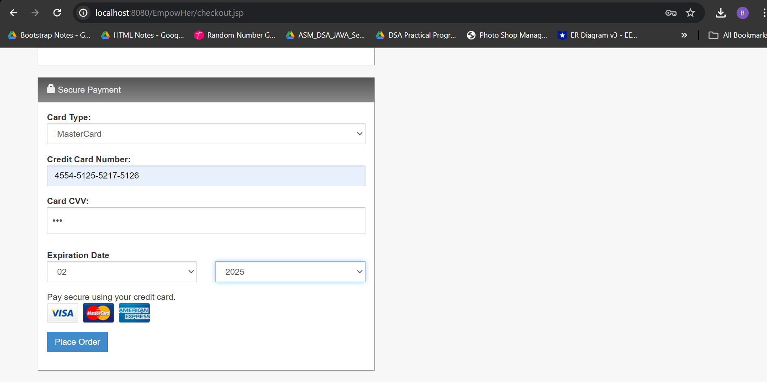

**Payment Successful**

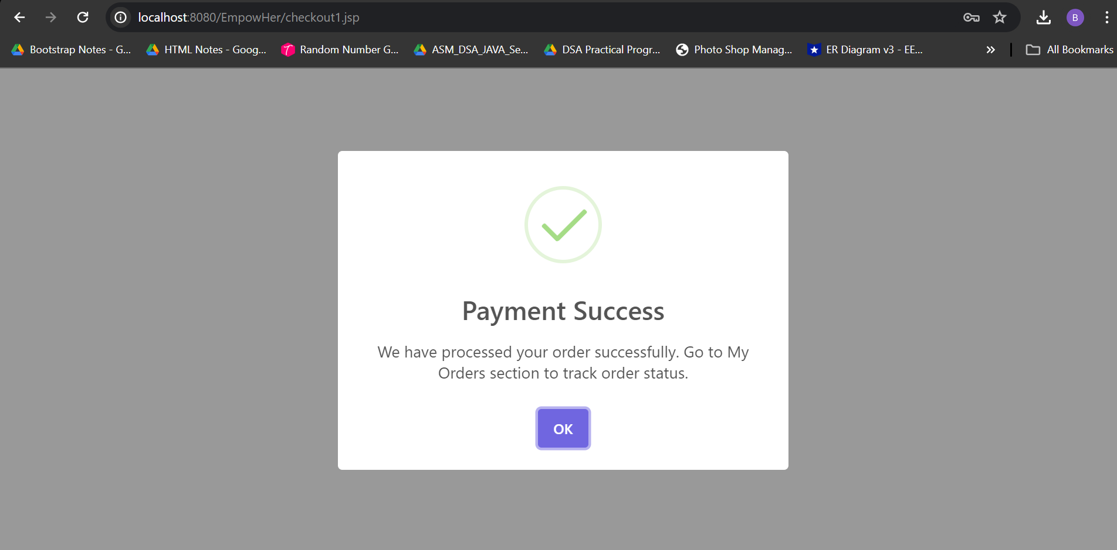

**My Order Page**

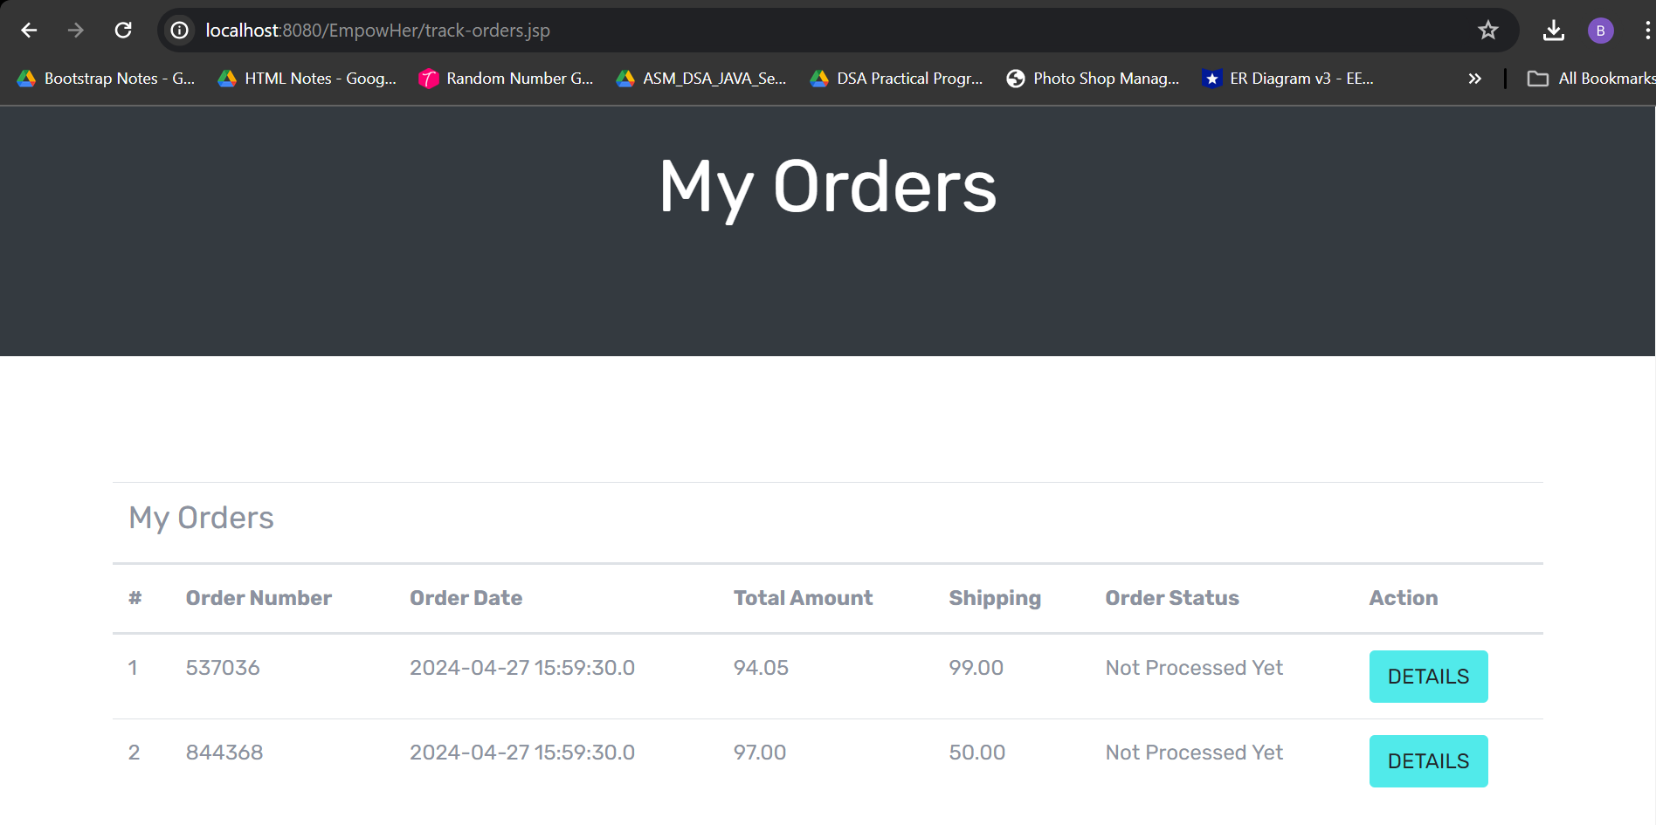

**My Order Details**

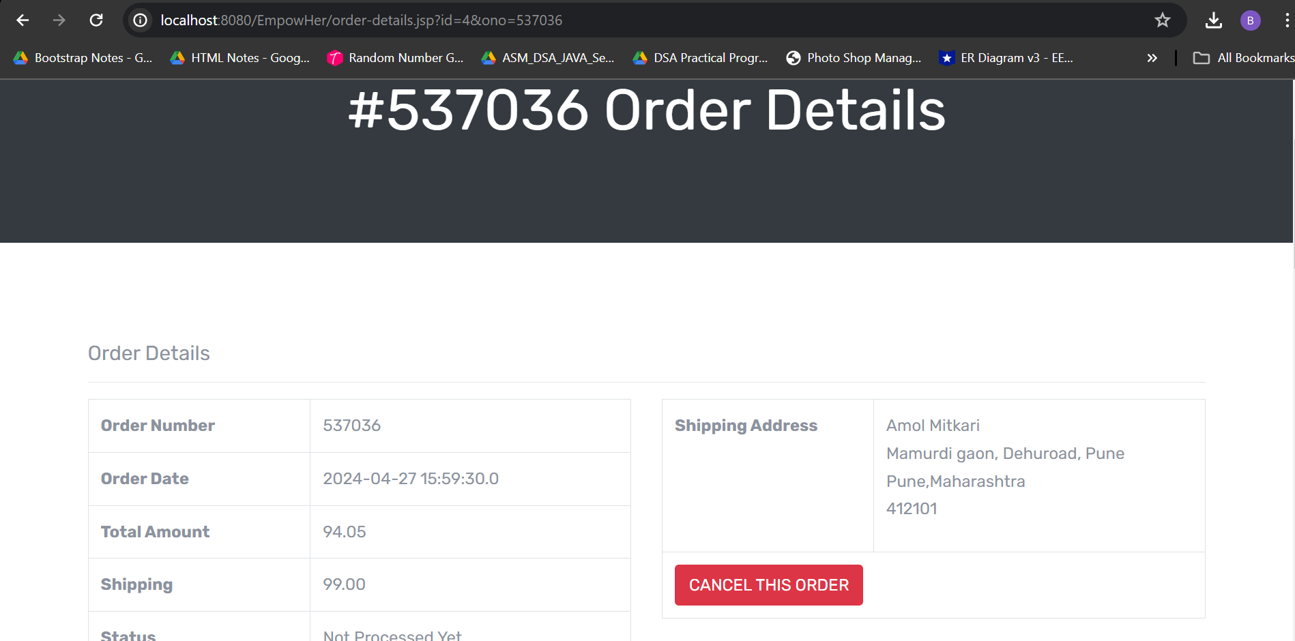

**Entrepreneurs Login**

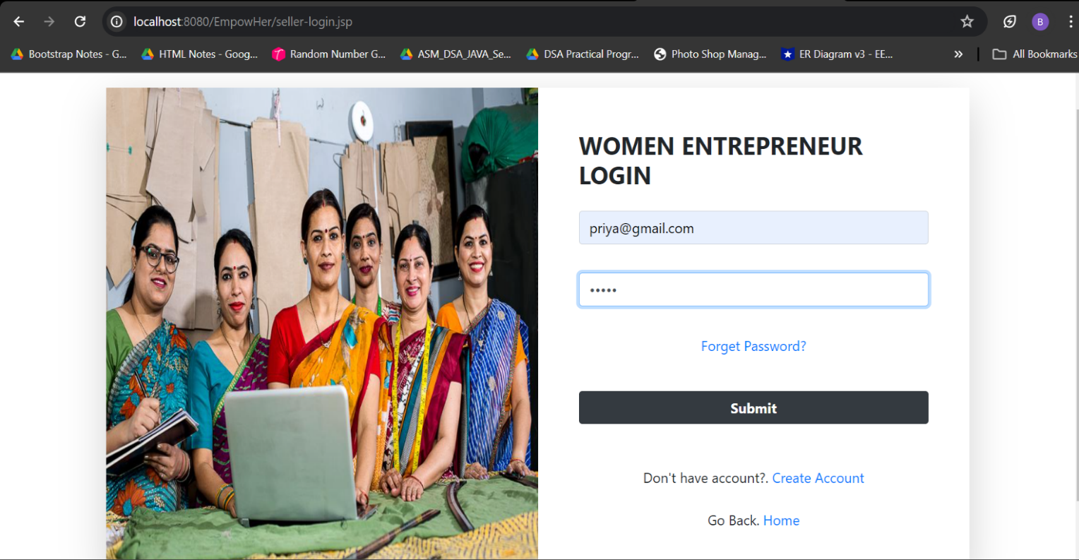

**Entrepreneur Login Failed**

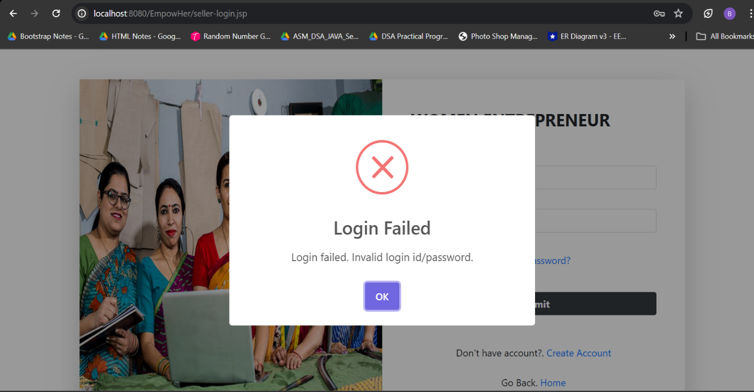

**Entrepreneur Login Successful**

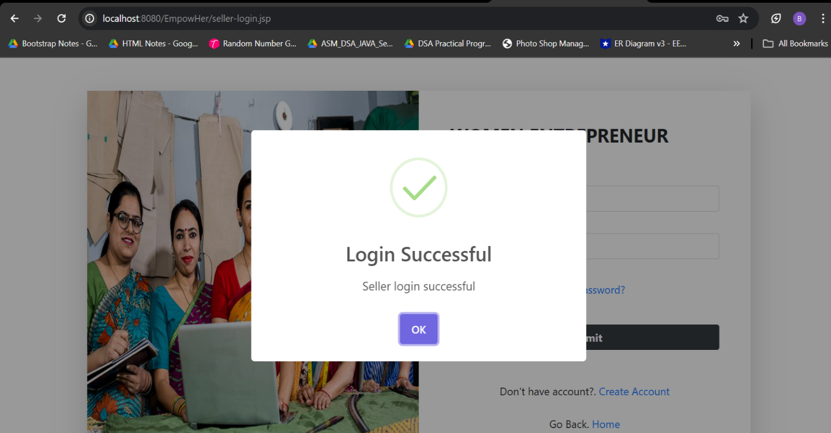

**Entrepreneur Dashboard**

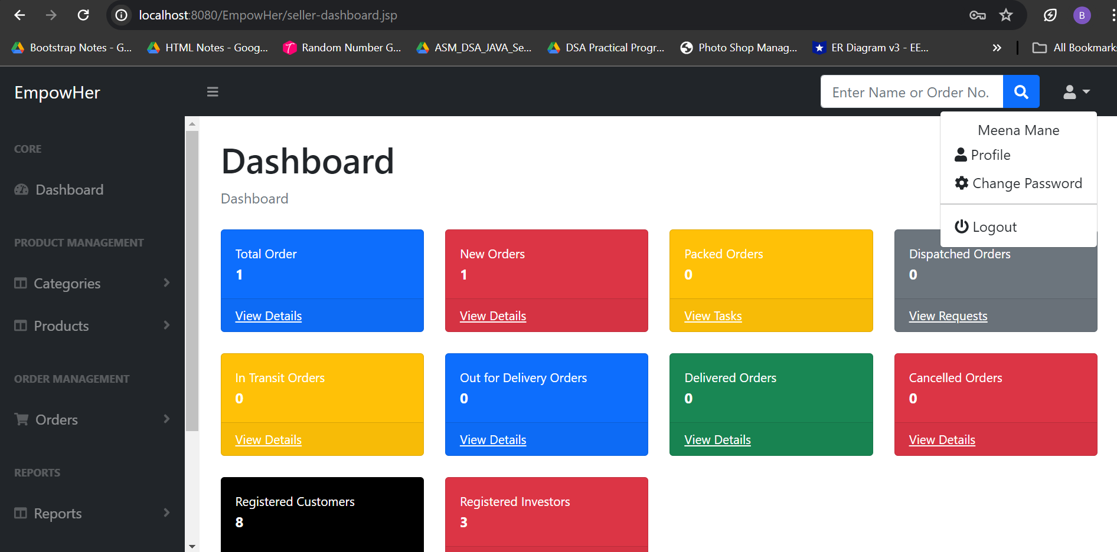

**Company Login**

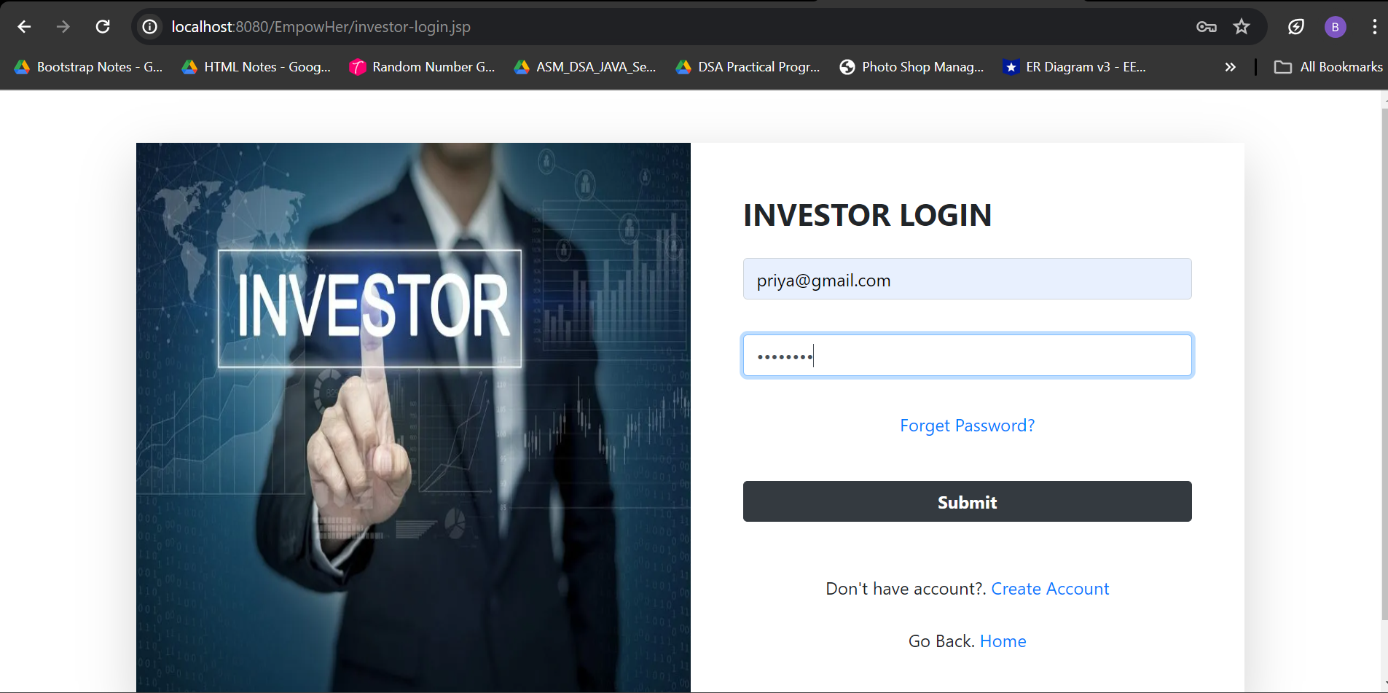

**Company Login Failed**

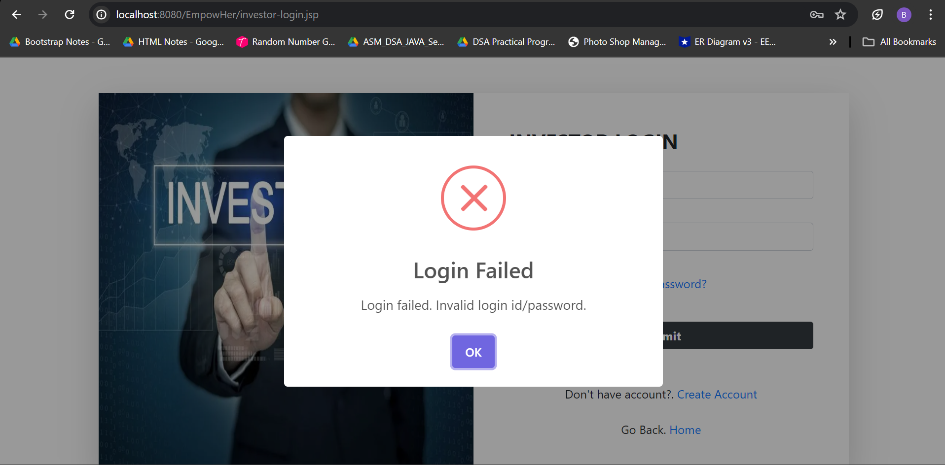

**Company Login Successful**

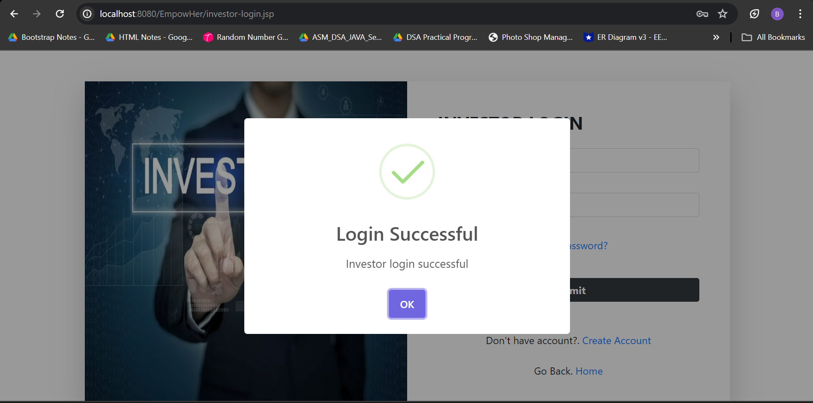

**Company Dashboard**

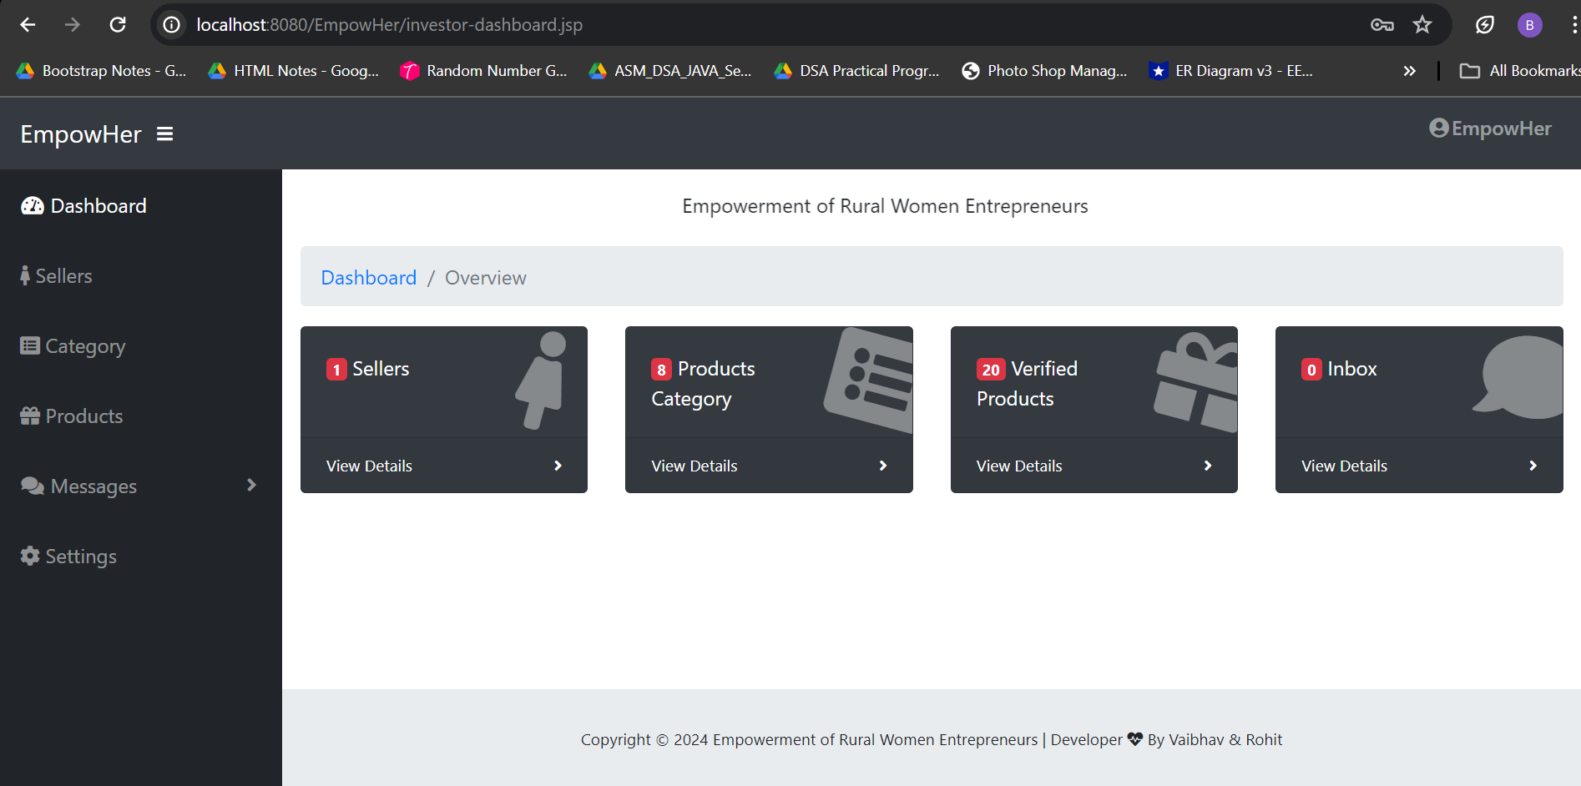

**3.10 Reports**

**Admin Dashboard**

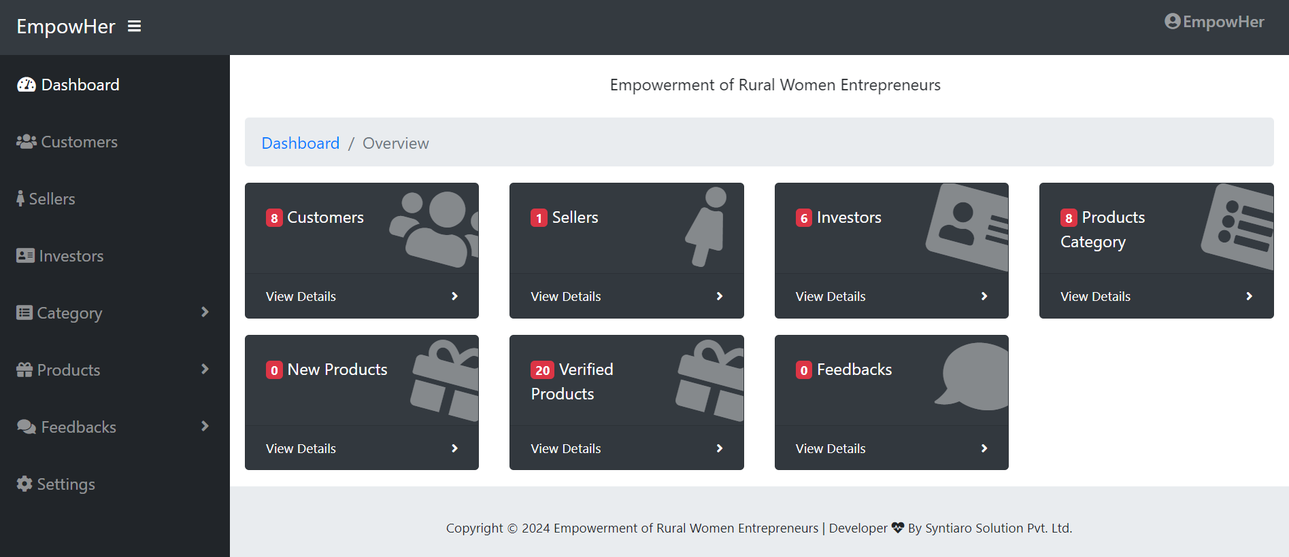

**Student Details**

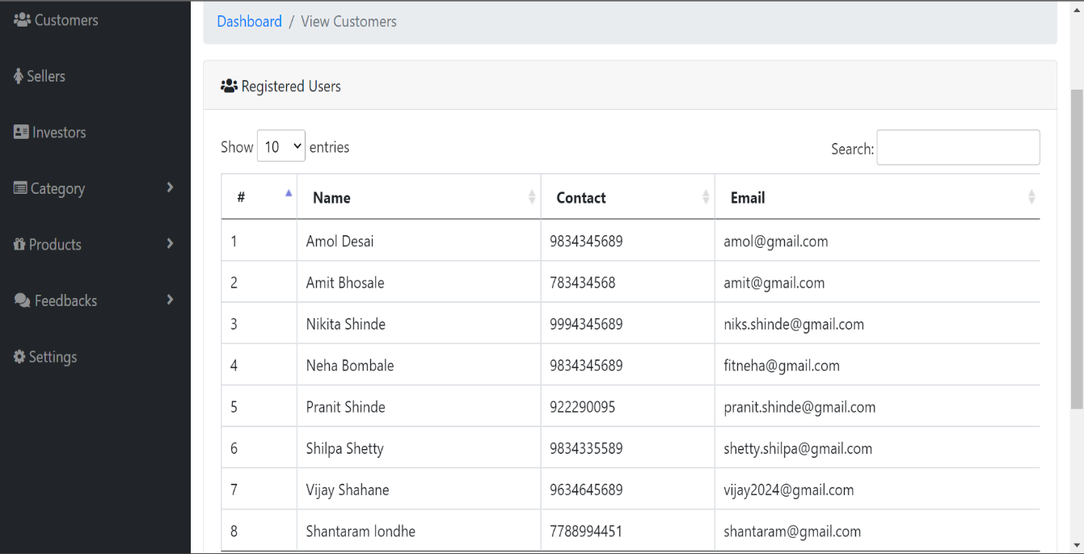

**Entrepreneurs Details**

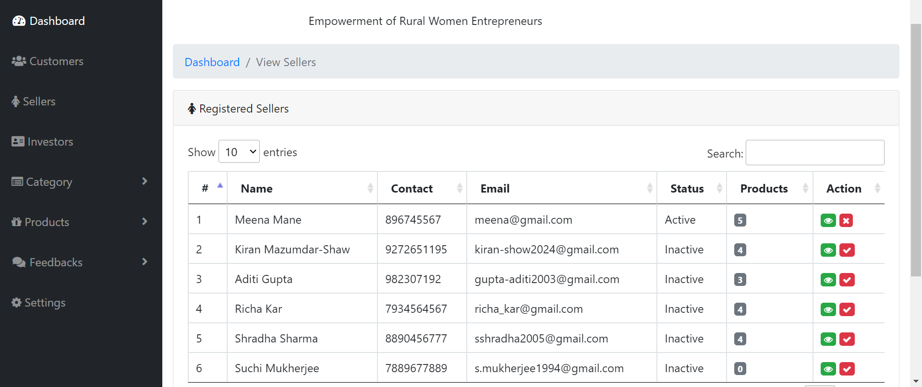

**Company Details**

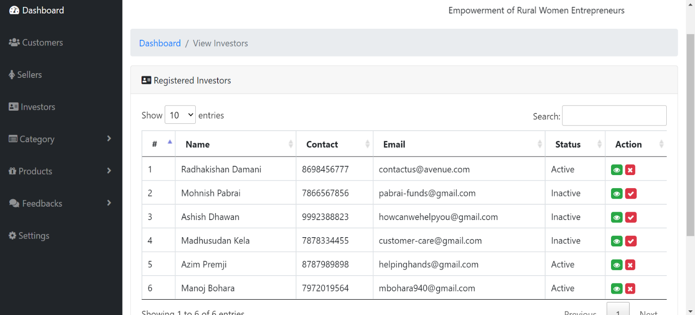

**Product Details**

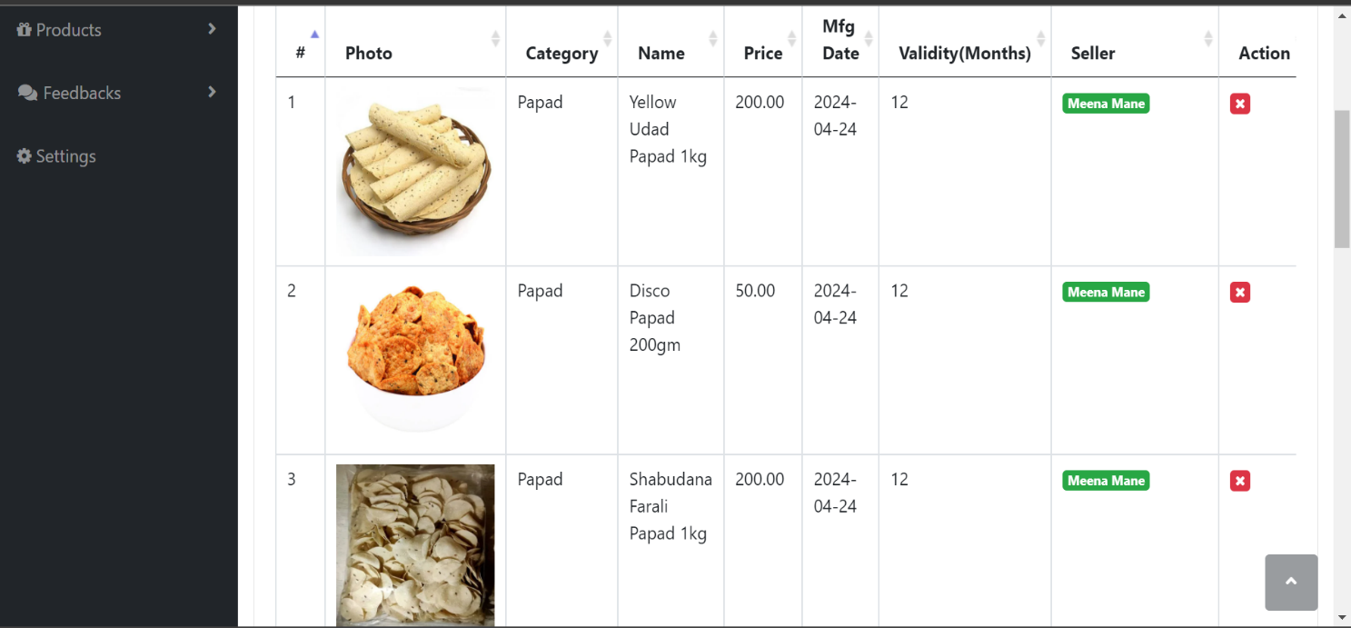

**Manage Orders**

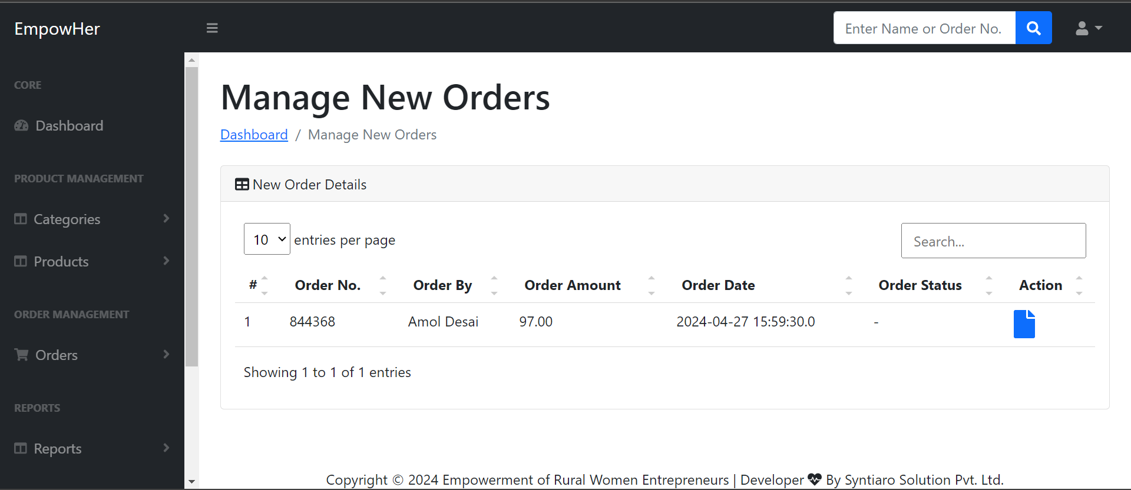

**Order Details**

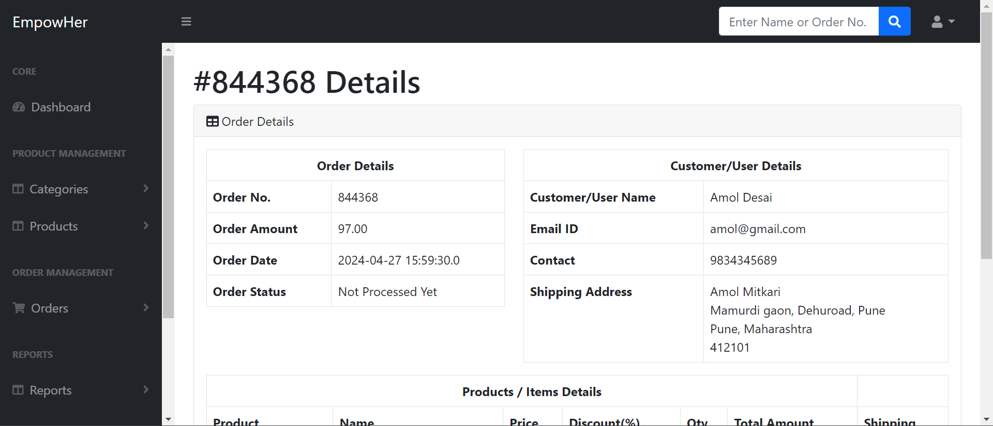

**Order Action**

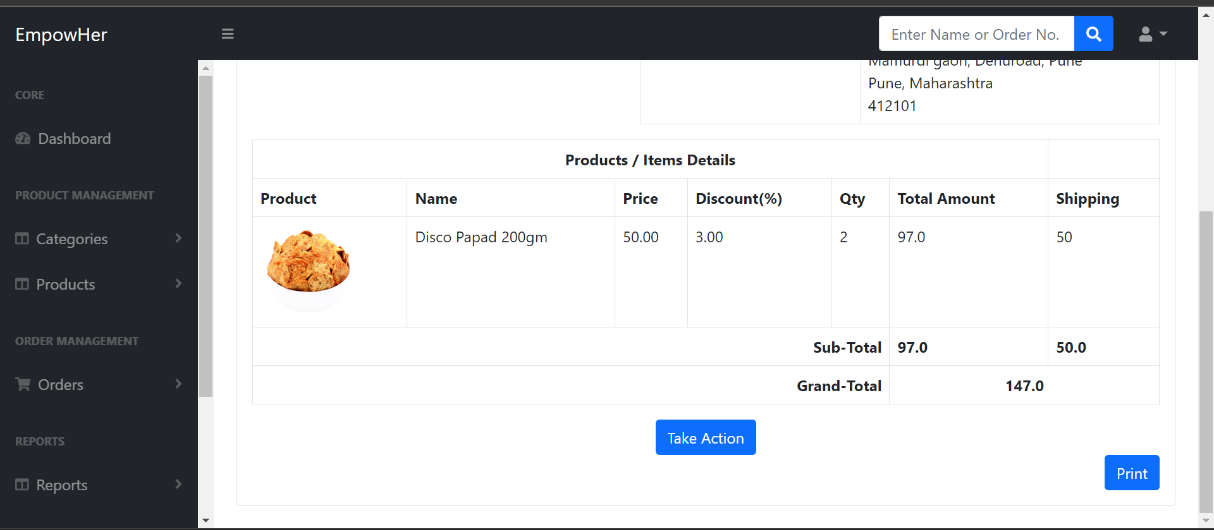

**CHAPTER 4**

**CODING**

**4.1 Algorithms**

1. **Admin Login(Algorithm):-**

Step 1: Start

Step 2: Connect to the database

Step 3: If the "submit" parameter is present

Step 4: Get the form data (email, password)

Step 5: Check if the email and password combination exist in the admin table

Step 6: If the combination exists

Step 7: Set the admin ID and name in the session

Step 8: Set a success message "Admin login successful"

Step 9: Else

Step 10: Set an error message "Email or password is not correct"

Step 11: End If

Step 12: End If

Step 13: Display the login page with the appropriate message

Step 14: If success, redirect to the admin dashboard

Step 15: End

1. **(A). Student Register (Algorithm):**

Step 1: Start

Step 2: Connect to the database

Step 3: If the "submit" parameter is present

Step 4: Get the form data (name, email, password, contact, university, major)

Step 5: Check if the email already exists in the database

Step 6: If the email exists

Step 7: Set an error message "Email already registered"

Step 8: Else

Step 9: Prepare an SQL statement to insert the student data

Step 10: Execute the SQL statement

Step 11: If the insertion is successful

Step 12: Set a success message "You are registered successfully”.

Step 13: Else

Step 14: Set an error message "Something went wrong”.

Step 15: End If

Step 16: End If

Step 17: End If

Step 18: Display the registration page with the appropriate message.

Step 19: End

**(B). Student Login:**

Step 1: Start

Step 2: Connect to the database

Step 3: If the "submit" parameter is present

Step 4: Get the form data (email, password)

Step 5: Check if the email exists in the student table

Step 6: If the email exists

Step 7: Retrieve the corresponding student's password from the database

Step 8: If the password matches the one provided

Step 9: Set the student ID, name, and other relevant information in the session

Step 10: Set a success message "Student login successful"

Step 11: Else

Step 12: Set an error message "Incorrect password"

Step 13: End If

Step 14: Else

Step 15: Set an error message "Email not found"

Step 16: End If

Step 17: End If

Step 18: Display the login page with the appropriate message

Step 19: If success, redirect to the student dashboard

Step 20: End

**(C). Applied company :**

Step 1: Start

Step 2: Connect to the database

Step 3: If the "submit" parameter is present

Step 4: Get the form data (student ID, company ID, job ID)

Step 5: Check if the student has already applied to the same job at the same company

Step 6: If the student has already applied

Step 7: Set an error message "You have already applied to this job at this company"

Step 8: Else

Step 9: Prepare an SQL statement to insert the application data into the applications table

Step 10: Execute the SQL statement

Step 11: If the insertion is successful

Step 12: Set a success message "Application submitted successfully"

Step 13: Else

Step 14: Set an error message "Failed to submit application"

Step 15: End If

Step 16: End If

Step 17: End If

Step 18: Display the appropriate message

Step 19: End

1. **Company Register (Algorithm):**

Step 1: Start

Step 2: Connect to the database

Step 3: If the "submit" parameter is present

Step 4: Get the form data (company name, email, password, contact, address, about us)

Step 5: Check if the email already exists in the company table

Step 6: If the email exists

Step 7: Set an error message "Company already registered"

Step 8: Else

Step 9: Prepare an SQL statement to insert the company data

Step 10: Execute the SQL statement

Step 11: If the insertion is successful

Step 12: Set a success message "You are registered successfully"

Step 13: Else

Step 14: Set an error message "Something went wrong"

Step 15: End If

Step 16: End If

Step 17: End If

Step 18: Display the registration page with the appropriate message

Step 19: If success, redirect to the company login page

Step 20: Else

Step 21: Check if the password and repeat password match

Step 22: If not matching

Step 23: Show an error message "Password mismatch"

Step 24: Return false (prevent form submission)

Step 25: End If

Step 26: End If

Step 27: End

**4.2 Code Snippet (Sample Code)**

1. **Admin Login:-**

<%@include file="db-connect.jsp"%>

<%

String success="", error="";

if(request.getParameter("submit")!=null){

String email=request.getParameter("email");

String pass=request.getParameter("pass");

ResultSet sel=con.createStatement().executeQuery("select * from admin where admin_email='"+email+"' and admin_pwd='"+pass+"'");

if(sel.next()){

session.setAttribute("aid", sel.getString("admin_id"));

session.setAttribute("name", sel.getString("admin_name"));

success = "Admin login successful";

}

else {

error = "Email or password is not correct";

}

}

%>

<html>

<head>

<title>Admin Login</title>

<link rel="stylesheet" href="https://cdnjs.cloudflare.com/ajax/libs/twitter-bootstrap/4.4.1/css/bootstrap.min.css">

<script src="https://use.fontawesome.com/f59bcd8580.js"></script>

<script src="https://cdn.jsdelivr.net/npm/sweetalert2@11.10.5/dist/sweetalert2.all.min.js"></script>

<link href="https://cdn.jsdelivr.net/npm/sweetalert2@11.10.5/dist/sweetalert2.min.css" rel="stylesheet">

</head>

<body>

<%

if(success.length()>0){

%>

<script type="text/javascript">

Swal.fire({

title: "Login Successful",

text: "<%=success%>",

icon: "success"

}).then(function() {

window.location.href = "admin-dashboard.jsp";

});

</script>

<%

}

if(error.length()>0){

%>

<script type="text/javascript">

Swal.fire({

title: "Login Failed",

text: "<%=error%>",

icon: "error"

});

</script>

<%

}

%>

<div class="container">

<div class="row m-5 no-gutters shadow-lg">

<div class="col-md-6 d-none d-md-block">

<img src="images/admin-login.png" class="img-fluid" style="min-height:100%;" />

</div>

<div class="col-md-6 bg-white p-5">

<h3 class="pb-3"><b>ADMIN LOGIN</b></h3>

<div class="form-style">

<form method="post" action="admin-login.jsp">

<div class="form-group pb-3">

<input type="email" name="email" placeholder="Email" class="form-control" id="exampleInputEmail1" aria-describedby="emailHelp" required>

</div>

<div class="form-group pb-3">

<input type="password" name="pass" placeholder="Password" class="form-control" id="exampleInputPassword1" required>

</div>

<div class="form-group pb-3">

<center><a href="admin-forgot-password.jsp">Forgot your password?</a></center>

</div>

<div class="pb-2">

<button type="submit" class="btn btn-dark w-100 font-weight-bold mt-2" name="submit">Submit</button>

</div>

</form>

</div>

<div class="pt-4 text-center">

Go Back. <a href="index.jsp">Home</a>

</div>

</div>

</div>

</div>

</body>

</html>

1. **(A). Student Register:-**

<%@include file="db-connect.jsp"%>

<%

String success="", error="";

if(request.getParameter("submit")!=null){

String name = request.getParameter("name");

String email = request.getParameter("email");

String password = request.getParameter("password");

String contact = request.getParameter("contact");

String sql = "SELECT * FROM Student WHERE cust_email='"+email+"'";

ResultSet rs = con.createStatement().executeQuery(sql);

if(rs.next()) {

error = "User already registred.";

}

else{

PreparedStatement ps = con.prepareStatement("insert into Student(cust_name, cust_phone, cust_email, cust_pwd) values(?,?,?,?)");

ps.setString(1, name);

ps.setString(2, contact);

ps.setString(3, email);

ps.setString(4, password);

if(ps.executeUpdate()>0){

success = "You are registered successfully";

}

else{

error = "Something went wrong";

}

}

}

%>

<!DOCTYPE html>

<html>

<head>

<meta charset="UTF-8">

<title>Student Sign Up</title>

<link rel="stylesheet" href="https://cdnjs.cloudflare.com/ajax/libs/twitter-bootstrap/4.4.1/css/bootstrap.min.css">

<script src="https://use.fontawesome.com/f59bcd8580.js"></script>

<script src="https://cdn.jsdelivr.net/npm/sweetalert2@11.10.5/dist/sweetalert2.all.min.js"></script>

<link href="https://cdn.jsdelivr.net/npm/sweetalert2@11.10.5/dist/sweetalert2.min.css" rel="stylesheet">

<script type="text/javascript">

function check()

{

pass = document.getElementById("password").value;

rpass = document.getElementById("rpassword").value;

if(pass != rpass)

{

Swal.fire({

title: "Password mismatch",

text: "Password doesn\'t match with repeat password",

icon: "error"

});

return false;

}

return true;

}

</script>

</head>

<body>

<%

if(success.length()>0){

%>

<script type="text/javascript">

Swal.fire({

title: "Signup Successful",

text: "<%=success%>",

icon: "success"

}).then(function() {

window.location.href = "Student-login.jsp";

});

</script>

<%

}

if(error.length()>0){

%>

<script type="text/javascript">

Swal.fire({

title: "Signup Failed",

text: "<%=error%>",

icon: "error"

});

</script>

<%

}

%>

<div class="container">

<div class="row m-5 no-gutters shadow-lg">

<div class="col-md-6 d-none d-md-block" style="padding: 50px;">

<img src="images/Student-login.png" class="img-fluid" style="min-height:50%;" />

</div>

<div class="col-md-6 bg-white p-5">

<h3 class="pb-3"><b>STUDENT SIGN UP</b></h3>

<div class="form-style">

<form method="post" onsubmit="return check()">

<div class="form-group"><input class="form-control" type="text" name="name" placeholder="Name" required></div>

<div class="form-group"><input class="form-control" type="email" name="email" placeholder="Email" required></div>

<div class="form-group"><input class="form-control" type="text" name="contact" placeholder="Contact Number" required></div>

<div class="form-group"><input class="form-control" type="password" id="password" name="password" placeholder="Password" required></div>

<div class="form-group"><input class="form-control" type="password" id="rpassword" name="password-repeat" placeholder="Password (repeat)" required></div>

<div class="form-group"><button class="btn btn-success btn-block" type="submit" name="submit">Sign Up</button></div>

<div class="form-group">

You already have an account? <a class="already" href="Student-login.jsp"> Login here.</a>

</div>

</form>

</div>

<div class="pt-4 text-center">

Go Back. <a href="index.jsp">Home</a>

</div>

</div>

</div>

</div>

</body>

</html>

**(B). Student Login:-**

<%@include file="db-connect.jsp" %>

<%

String success="", error="";

if(request.getParameter("submit")!=null){

String email = request.getParameter("email");

String pass = request.getParameter("pass");

ResultSet rs = con.createStatement().executeQuery("select * from Student where cust_email = '"+email+"' and cust_pwd = '"+pass+"'");

if(rs.next()){

session.setAttribute("uid", rs.getString(1));

session.setAttribute("name", rs.getString(2));

success = "Student login successful";

}

else{

error = "Login failed. Invalid login id/password.";

}

}

%>

<html>

<head>

<title>Student Login</title>

<link rel="stylesheet" href="https://cdnjs.cloudflare.com/ajax/libs/twitter-bootstrap/4.4.1/css/bootstrap.min.css">

<script src="https://use.fontawesome.com/f59bcd8580.js"></script>

<script src="https://cdn.jsdelivr.net/npm/sweetalert2@11.10.5/dist/sweetalert2.all.min.js"></script>

<link href="https://cdn.jsdelivr.net/npm/sweetalert2@11.10.5/dist/sweetalert2.min.css" rel="stylesheet">

</head>

<body>

<%

if(success.length()>0){

%>

<script type="text/javascript">

Swal.fire({

title: "Login Successful",

text: "<%=success%>",

icon: "success"

}).then(function() {

window.location.href = "index.jsp";

});

</script>

<%

}

if(error.length()>0){

%>

<script type="text/javascript">

Swal.fire({

title: "Login Failed",

text: "<%=error%>",

icon: "error"

});

</script>

<%

}

%>

<div class="container">

<div class="row m-5 no-gutters shadow-lg">

<div class="col-md-6 d-none d-md-block" style="padding: 50px;">

<img src="images/Student-login.png" class="img-fluid" style="min-height:50%;" />

</div>

<div class="col-md-6 bg-white p-5">

<h3 class="pb-3"><b>STUDENT LOGIN</b></h3>

<div class="form-style">

<form method="post">

<div class="form-group pb-3">

<input type="email" placeholder="Email" name="email" class="form-control" id="exampleInputEmail1" aria-describedby="emailHelp" required>

</div>

<div class="form-group pb-3">

<input type="password" placeholder="Password" name="pass" class="form-control" id="exampleInputPassword1" required>

</div>

<div class="form-group pb-3">

<div><center><a href="Student-forgot-password.jsp">Forget Password?</a></center></div>

</div>

<div class="pb-2">

<button type="submit" class="btn btn-dark w-100 font-weight-bold mt-2" name="submit">Submit</button>

</div>

</form>

</div>

<div class="pt-4 text-center">

Don't have account?. <a href="Student-register.jsp">Create Account</a>

</div>

<div class="pt-4 text-center">

Go Back. <a href="index.jsp">Home</a>

</div>

</div>

</div>

</div>

</body>

</html>

**(C). Student Order:-**

<%@include file="db-connect.jsp"%>

<%

if(session.getAttribute("sid")==null){

response.sendRedirect("admin-logout.jsp");

return;

}

%>

?>

<!DOCTYPE html>

<html lang="en">

<head>

<meta charset="utf-8" />

<meta http-equiv="X-UA-Compatible" content="IE=edge" />

<meta name="viewport" content="width=device-width, initial-scale=1, shrink-to-fit=no" />

<meta name="description" content="" />

<meta name="author" content="" />

<title>EmpowHer | Student Orders</title>

<link href="https://cdn.jsdelivr.net/npm/simple-datatables@latest/dist/style.css" rel="stylesheet" />

<link href="css/admin-styles.css" rel="stylesheet" />

<script src="js/all.min.js" crossorigin="anonymous"></script>

</head>

<body class="sb-nav-fixed">

<%@include file="seller-header.jsp"%>

<div id="layoutSidenav">

<%@include file="seller-sidebar.jsp"%>

<div id="layoutSidenav_content">

<main>

<%

String userid = request.getParameter("uid");

String username = request.getParameter("uname");

%>

<div class="container-fluid px-4">

<h1 class="mt-4">Manage <%=username%>'s Orders</h1>

<ol class="breadcrumb mb-4">

<li class="breadcrumb-item"><a href="seller-dashboard.jsp">Dashboard</a></li>

<li class="breadcrumb-item active">Manage <%=username%>'s Orders</li>

</ol>

<div class="card mb-4">

<div class="card-header">

<i class="fas fa-table me-1"></i>

All Order Details

</div>

<div class="card-body">

<table id="datatablesSimple">

<thead>

<tr>

<th>#</th>

<th>Order No.</th>

<th>Order By</th>

<th>Order Amount</th>

<th>Order Date</th>

<th>Order Status</th>

<th>Action</th>

</tr>

</thead>

<tbody>

<%

ResultSet query = con.createStatement().executeQuery("SELECT orders.order_id,orderNumber,totalAmount,orderStatus,orderDate,Student.cust_name,Student.cust_phone FROM orders join Student on Student.cust_id=orders.cust_id where orders.cust_id="+userid+" and prod_id in (select prod_id from products where seller_id="+session.getAttribute("sid")+")");

int cnt=1;

while(query.next()){

%>

<tr>

<td><%=cnt++%></td>

<td><%=query.getString("orderNumber")%></td>

<td><%=query.getString("cust_name")%></td>

<td><%=query.getString("totalAmount")%></td>

<td><%=query.getString("orderDate")%></td>

<td><%=query.getString("orderStatus")==null?"-":query.getString("orderStatus")%></td>

<td>

<a href='order-details.jsp?orderid=<%=query.getInt("order_id")%>'>

<i class="fas fa-file fa-2x" title="View Order Details"></i></a></td>

</tr>

<% } %>

</tbody>

</table>

</div>

</div>

</div>

</main>

<%@include file="admin-footer.jsp"%>

</footer>

</div>

</div>

<script src="js/bootstrap.bundle.min.js" crossorigin="anonymous"></script>

<script src="js/admin-scripts.js"></script>

<script src="https://cdn.jsdelivr.net/npm/simple-datatables@latest" crossorigin="anonymous"></script>

<script src="js/datatables-simple-demo.js"></script>

</body>

</html>

1. **(A). Entrepreneurs Register:-**

<%@include file="db-connect.jsp"%>

<%

String success="", error="";

if(request.getParameter("submit")!=null){

String name = request.getParameter("name");

String email = request.getParameter("email");

String password = request.getParameter("password");

String contact = request.getParameter("contact");

String addr = request.getParameter("addr");

String aboutus = request.getParameter("aboutus");

String bname = request.getParameter("bname");

String sql = "SELECT * FROM seller WHERE seller_email='"+email+"'";

ResultSet rs = con.createStatement().executeQuery(sql);

if(rs.next()) {

error = "Entrepreneur already registred.";

}

else{

PreparedStatement ps = con.prepareStatement("insert into seller(seller_name, seller_phone, seller_email, seller_pwd, seller_business_name, seller_address, seller_about_us) values(?, ?, ?, ?, ?, ?, ?)");

ps.setString(1, name);

ps.setString(2, contact);

ps.setString(3, email);

ps.setString(4, password);

ps.setString(5, bname);

ps.setString(6, addr);

ps.setString(7, aboutus);

if(ps.executeUpdate()>0){

success = "You are registered successfully";

}

else{

error = "Something went wrong";

}

}

}

%>

<!DOCTYPE html>

<html>

<head>

<meta charset="UTF-8">

<title>Entrepreneur Sign Up</title>

<link rel="stylesheet" href="https://cdnjs.cloudflare.com/ajax/libs/twitter-bootstrap/4.4.1/css/bootstrap.min.css">

<script src="https://use.fontawesome.com/f59bcd8580.js"></script>

<script src="https://cdn.jsdelivr.net/npm/sweetalert2@11.10.5/dist/sweetalert2.all.min.js"></script>

<link href="https://cdn.jsdelivr.net/npm/sweetalert2@11.10.5/dist/sweetalert2.min.css" rel="stylesheet">

<script type="text/javascript">

function check()

{

pass = document.getElementById("password").value;

rpass = document.getElementById("rpassword").value;

if(pass != rpass)

{

Swal.fire({

title: "Password mismatch",

text: "Password doesn\'t match with repeat password",

icon: "error"

});

return false;

}

return true;

}

</script>

</head>

<body>

<%

if(success.length()>0){

%>

<script type="text/javascript">

Swal.fire({

title: "Signup Successful",

text: "<%=success%>",

icon: "success"

}).then(function() {

window.location.href = "seller-login.jsp";

});

</script>

<%

}

if(error.length()>0){

%>

<script type="text/javascript">

Swal.fire({

title: "Signup Failed",

text: "<%=error%>",

icon: "error"

});

</script>

<%

}

%>

<div class="container">

<div class="row m-5 no-gutters shadow-lg">

<div class="col-md-6 d-none d-md-block" style="padding: 50px;">

<img src="images/seller-login.png" class="img-fluid" style="min-height:50%;" />

</div>

<div class="col-md-6 bg-white p-5">

<h3 class="pb-3"><b>WOMEN ENTREPRENEUR<br>SIGN UP</b></h3>

<div class="form-style">

<form method="post" onsubmit="return check()">

<div class="form-group"><input class="form-control" type="text" name="name" placeholder="Name" required></div>

<div class="form-group"><input class="form-control" type="text" name="contact" placeholder="Contact Number" required></div>

<div class="form-group"><input class="form-control" type="email" name="email" placeholder="Email" required></div>

<div class="form-group"><input class="form-control" type="password" id="password" name="password" placeholder="Password" required></div>

<div class="form-group"><input class="form-control" type="password" id="rpassword" name="password-repeat" placeholder="Password (repeat)" required></div>

<div class="form-group"><input class="form-control" type="text" name="bname" placeholder="Business Name" required></div>

<div class="form-group"><textarea class="form-control" rows="4" cols="40" placeholder="Address" name="addr" required></textarea></div>

<div class="form-group"><textarea class="form-control" rows="4" cols="40" placeholder="About Business" name="aboutus" required></textarea></div>

<div class="form-group"><button class="btn btn-dark w-100 font-weight-bold mt-2" type="submit" name="submit">Sign Up</button></div>

<div class="form-group">

You already have an account? <a class="already" href="seller-login.jsp"> Login here.</a>

</div>

</form>

</div>

<div class="pt-4 text-center">

Go Back. <a href="index.jsp">Home</a>

</div>

</div>

</div>

</div>

</body>

</html>

**(B). Entrepreneurs Login:-**

<%@include file="db-connect.jsp" %>

<%

String success="", error="";

if(request.getParameter("submit")!=null){

String email = request.getParameter("email");

String pass = request.getParameter("pass");

ResultSet rs = con.createStatement().executeQuery("select * from seller where seller_email = '"+email+"' and seller_pwd = '"+pass+"'");

if(rs.next()){

session.setAttribute("sid", rs.getString(1));

session.setAttribute("sname", rs.getString(2));

success = "Seller login successful";

}

else{

error = "Login failed. Invalid login id/password.";

}

}

%>

<html>

<head>

<title>Entrepreneur Login</title>

<link rel="stylesheet" href="https://cdnjs.cloudflare.com/ajax/libs/twitter-bootstrap/4.4.1/css/bootstrap.min.css">

<script src="https://use.fontawesome.com/f59bcd8580.js"></script>

<script src="https://cdn.jsdelivr.net/npm/sweetalert2@11.10.5/dist/sweetalert2.all.min.js"></script>

<link href="https://cdn.jsdelivr.net/npm/sweetalert2@11.10.5/dist/sweetalert2.min.css" rel="stylesheet">

</head>

<body>

<%

if(success.length()>0){

%>

<script type="text/javascript">

Swal.fire({

title: "Login Successful",

text: "<%=success%>",

icon: "success"

}).then(function() {

window.location.href = "seller-dashboard.jsp";

});

</script>

<%

}

if(error.length()>0){

%>

<script type="text/javascript">

Swal.fire({

title: "Login Failed",

text: "<%=error%>",

icon: "error"

});

</script>

<%

}

%>

<div class="container">

<div class="row m-5 no-gutters shadow-lg">

<div class="col-md-6 d-none d-md-block">

<img src="images/seller-login.png" class="img-fluid" style="min-height:100%;" />

</div>

<div class="col-md-6 bg-white p-5">

<h3 class="pb-3"><b>WOMEN ENTREPRENEUR LOGIN</b></h3>

<div class="form-style">

<form method="post">

<div class="form-group pb-3">

<input type="email" placeholder="Email" name="email" class="form-control" id="exampleInputEmail1" aria-describedby="emailHelp" required>

</div>

<div class="form-group pb-3">

<input type="password" placeholder="Password" name="pass" class="form-control" id="exampleInputPassword1" required>

</div>

<div class="form-group pb-3">

<div><center><a href="seller-forgot-password.jsp">Forget Password?</a></center></div>

</div>

<div class="pb-2">

<button type="submit" class="btn btn-dark w-100 font-weight-bold mt-2" name="submit">Submit</button>

</div>

</form>

</div>

<div class="pt-4 text-center">

Don't have account?. <a href="seller-register.jsp">Create Account</a>

</div>

<div class="pt-4 text-center">

Go Back. <a href="index.jsp">Home</a>

</div>

</div>

</div>

</div>

</body>

</html>

**CHAPTER 5**

**TESTING**

**5.1 Test Strategy**

* **Test Strategy: Online Campus Recruitment**

1. **Objective**:

The objective of test strategies for online campus recruitment is to validate the functionality, usability, and security of the platform. This involves ensuring that all features work as intended, the interface is intuitive for both students and employers, and the system is robust against potential security threats. Through comprehensive testing, the aim is to deliver a reliable and user-friendly platform that enhances the recruitment experience for all stakeholders.

1. **Scope:**

The testing scope covers the following essential modules of the online campus recruitment:

* **Admin Module:**
  + User management (add, edit, delete users).
  + Job posting management (create, edit, delete job postings).
  + Application management (view, filter, process job applications).
  + Communication tools (messaging, notifications to students and employers).
  + System configuration (settings, permissions).
* **Student Module:**
* Registration and login.
* Profile management (update profile, upload resume).
* Job search, filtering, and browsing.
* Application submission and tracking.
* Communication tools (messaging, scheduling interviews).
* **Employer Module:**
* Registration and login.
* Company profile setup and management.
* Job posting (create, edit, delete job postings).
* Application management (view, filter, process job applications).
* Communication tools (messaging, scheduling interviews).
* **Job Search Module:**
* Search functionality based on criteria such as location, job title, industry, etc.
* Filtering options to narrow down job search results.
* Display of job details, requirements, and application instructions.
* **Communication Module:**
* Messaging system for real-time communication between students and employers.
* Email notifications for important updates such as application status changes, interview invitations, etc.
* Integration with calendar tools for scheduling interviews.
* **Data Management Module:**
* Storage and retrieval of user data (students, employers).
* Job postings and application data management.
* Security measures to protect sensitive information.
* **User Experience Testing:**
* Evaluate the overall user experience of the platform across different modules.
* Ensure that the interface is intuitive, responsive, and user-friendly.
* Test compatibility with various devices and browsers.
* **Security Testing:**
* Assess the platform's security measures to protect user data and prevent unauthorized access.
* Test for vulnerabilities such as SQL injection, cross-site scripting (XSS), and data breaches.
* Ensure compliance with data protection regulations (e.g., GDPR).
* By covering these essential modules and aspects, the test strategies aim to validate the functionality, usability, and security of the online campus recruitment platform, ensuring a seamless experience for both students and employers.

1. **Testing Tools:**

The following tools will be utilized for efficient test management and execution:

* **Test Management:** JIRA for test case management, defect tracking, and overall project visibility.
* **Automation:** Selenium WebDriver for GUI automation and Postman for API testing.
* **Performance:** JMeter for load testing to evaluate system scalability and response times.
* **Compatibility:** Browser Stack for cross-browser compatibility testing across popular browsers.

1. **Test Deliverables:**

The testing deliverables will include:

* **Test Plan:** Document outlining the testing approach, scope, schedule, and responsibilities.
* **Test Cases:** Comprehensive test cases covering positive, negative, and edge cases for each module.
* **Test Scripts:** Automated test scripts for critical workflows and regression testing.
* **Defect Reports:** Detailed reports on identified issues including severity, priority, and steps to reproduce.
* **Test Execution Logs:** Records of test execution activities, outcomes, and test coverage.

1. **Schedule and Milestones:**

The testing activities will be structured based on the project timeline and milestones:

* **Test Planning:** Define test strategy and prepare test artifacts - 1 week.
* **Test Execution:** Conduct functional, usability, performance, and security testing - 2 weeks.
* **Defect Management:** Report, triage, and validate defects in collaboration with the development team - Ongoing throughout the project.

1. **Roles and Responsibilities:**

**Quality Assurance (QA) Team:**

* Test planning, preparation, and execution.
* Test case development and maintenance.
* Defect identification, reporting, and verification.

**Development Team:**

* Collaboration with QA for defect resolution and validation of fixes.
* Support during testing activities and environment setup.

1. **Risks and Assumptions:**

* **Risks:**
* Limited network connectivity affecting remote testing in rural areas.
* Integration challenges with external systems or services.
* **Assumptions:**
* Availability of representative test data and environments.
* Timely resolution of critical defects by the development team.

1. **Communication and Reporting:**

Regular communication channels will be established between the QA team, development team, and project stakeholders to ensure transparency, alignment, and timely resolution of issues identified during testing.

**5.2 Test Cases/Test Scripts:**

* **Test Case: Admin**

|  |  |  |  |  |  |
| --- | --- | --- | --- | --- | --- |
| **Test Case ID** | **Test Steps** | **Test Input** | **Expected Result** | **Actual Result** | **Status** |
| TC_Admin_001 | 1. Enter valid admin username  2. Enter valid password  3. Click the "Login" button | username=”admin2@gmail.com”  Password=admin2 | The admin should be successfully logged in and redirected to the admin dashboard. | The admin was successfully logged in and redirected to the admin dashboard. | Pass |
| TC_Admin_002 | 1. Enter valid admin username  2. Enter valid password  3. Click the "Login" button | username=”admin@gmail.com”  Password=admin1 | The admin should be successfully logged in and redirected to the admin dashboard. | Error Message  Generate. | Fail |
| TC_Admin_003 | 1. Navigate to the "Add Student" page.  2. Enter valid Student details (name, contact, etc.)  3. Click the "Save" button | Name: Priya Patil  Email: [priya99@gmail.com](mailto:priya99@gmail.com)  Phone: +91 7072019564 | The new Student should be added successfully, and a confirmation message should be displayed. | The new Student was added successfully, and a confirmation message was displayed | Pass |

|  |  |  |  |  |  |
| --- | --- | --- | --- | --- | --- |
| **Test Case ID** | **Test Steps** | **Test Input** | **Expected Result** | **Actual Result** | **Status** |
| TC_Admin_004 | 1. Navigate to the "Students" list.  2. Select an existing Student from the list.  3. Update the Student details (e.g., contact information, business details).  4. Click the "Save" button | Updated Email: [priya01@gmail.com](mailto:priya01@gmail.com)  Updated Phone: +91 797265486  Updated Business Name: Eco-Friendly Arts and Crafts | The Student details should be updated successfully, and a confirmation message should be displayed. | The Student details were updated successfully, and a confirmation message was displayed. | Pass |
| TC_Admin_005 | 1. Navigate to the "Students" list.  2. Select an existing Student from the list.  3. Click the "Delete" button.  4. Confirm the deletion | Student to be deleted: Priya Patil [priya01@gmail.com](mailto:priya01@gmail.com) | The selected Student should be deleted successfully, and a confirmation message should be displayed | An error occurred during deletion, and the Student was not deleted. | Fail |
| TC_Admin_006 | 1. Navigate to the "Add Company" page.  2. Enter valid Company details (name, email, contact information, etc.)  3. Click the "Save" buttondetails (name, contact etc.)  4. Click the "Save" button | Name: Manoj Bohara  Email: [mbohara940@gmail.com](mailto:mbohara940@gmail.com)  Phone: +91 7972019564 | The new Company should be added successfully, and a confirmation message should be displayed. | The new Company was added successfully, and a confirmation message was displayed | Pass |

* **Test Case: Student**

|  |  |  |  |  |  |
| --- | --- | --- | --- | --- | --- |
| **Test Case ID** | **Test Steps** | **Test Input** | **Expected Result** | **Actual Result** | **Status** |
| TC_Student_001 | 1. Enter valid Student username  2. Enter valid password  3. Click the "Login" button | username=”Student2@gmail.com”  Password=Student2 | The Student should be successfully logged in and redirected to the Student dashboard. | The Student was successfully logged in and redirected to the Student dashboard. | Pass |
| TC_Student_002 | 1. Enter valid Student username  2. Enter valid password  3. Click the "Login" button | username=”Student@gmail.com”  Password=Student1 | The Student should be successfully logged in and redirected to the Student dashboard. | Error Message  Generate. | Fail |
| TC_Student_003 | 1. Navigate to the "Add Student" page.  2. Enter valid Student details (name, contact etc.)  3. Click the "Save" button | Name: Priya Patil  Email: [priya99@gmail.com](mailto:priya99@gmail.com)  Phone: +91 7072019564 | The new Student should be added successfully, and a confirmation message should be displayed. | The new Student was added successfully, and a confirmation message was displayed | Pass |

|  |  |  |  |  |  |
| --- | --- | --- | --- | --- | --- |
| **Test Case ID** | **Test Steps** | **Test Input** | **Excepted Result** | **Actual Result** | **Status** |
| TC_Student_001 | 1. Open the application.  2. Navigate to the Student registration page.  3. Enter valid Student details (name, business information, contact information, etc.).  4. Click the "Register" button | Name: Priya Patil  Business Name: Eco-Friendly Crafts  Business Category: Handicrafts  Email: [priya01@gmail.com](mailto:priya01@gmail.com)  Phone: +91 7972019564  Address: Nigdi, Pune | The Student should be registered successfully, and a confirmation message should be displayed Actual Result. | The Student was registered successfully, and a confirmation message was displayed. | Pass |
| TC_Student_002 | 1. Navigate to the "Profile" section.  2. Update the profile information (e.g., business details, contact information).  3. Click the "Save" button. | Updated Business Name: Eco-Friendly Arts and Crafts  Updated Phone: +91 7972019564 | The Student's profile should be updated successfully, and a confirmation message should be displayed. | The Student's profile was updated successfully, and a confirmation message was displayed. | Pass |
| TC_Student_003 | 1. Navigate to the "Products/Services" section.  2. Click the "Add New" button.  3. Enter the product/service details (name, description, price, etc.).  4. Click the "Save" button. | Product Name: Handmade Ceramic Vase  Description: Unique, hand-painted ceramic vase  Price: Rs. 50.00 | The new product/service should be added successfully, and a confirmation message should be displayed. | The new product/service was added successfully, and a confirmation message was displayed. | Pass |
| TC_Student_004 | 1. Log in as an Student.  2. Navigate to the "Orders" section.  3. Observe the list of orders | N/A | The Student should be able to view the list of orders placed by Students for their products/services. | No orders were displayed, and an error message was shown: "Unable to retrieve order data". | Fail |

* **Test Case: Company**

|  |  |  |  |  |  |
| --- | --- | --- | --- | --- | --- |
| **Test Case ID** | **Description** | **Pre-conditions** | **Test Steps** | **Expected Result** | **Post-consition** |
| TC_Company_001 | 1. Open the Company login page.  2. Enter valid Company credentials (username and password).  3. Click on the "Login" button. | username: Manoj Bohara  Password: manoj@123 | Upon successful login, the Company should be redirected to the Company dashboard. | After entering valid credentials and clicking "Login", the Company dashboard loads successfully. | Pass |
| TC_Company_002 | 1. From the Company dashboard, navigate to the section displaying rural women Students seeking investment opportunities.  2. View the list of available Students. | Navigate to the "Students" tab in the Company dashboard. | A list of rural women Students actively seeking investment should be displayed. | The list of rural women Students seeking investment is visible under the "Students" section.. | Pass |
| TC_Company_003 | 1. Select a specific Student from the list for further details.  2. Click on the entrepreneur's profile to view more information. | Choose an entrepreneur from the displayed list. | The Company should be able to view detailed information about the selected entrepreneur, including their business pitch and funding requirements. | Detailed information about the selected entrepreneur, such as business pitch and funding requirements, is displayed. | Pass |
| TC_Company_004 | 1. Initiate a chat or communication with the selected entrepreneur.  2. Send a message or inquiry through the Company platform. | Click on the chat icon next to the entrepreneur's profile.  Type and send a message or inquiry. | The chat feature should allow real-time communication between the Company and the entrepreneur. | The chat functionality works as expected, enabling real-time communication with the selected entrepreneur. | Pass |

**CHAPTER 6**

**LIMITATIONS OF PROPOSED SYSTEM**

**6. LIMITATIONS OF PROPOSED SYSTEM**

1. **Digital Divide :**

The reliance on an online platform may exclude students who lack access to reliable internet connectivity or digital devices, potentially widening the digital divide and limiting the participation of certain demographics.

1. **Technical Challenges:**

The success of the platform relies heavily on the reliability of the underlying technology infrastructure. Technical issues such as server downtime, software bugs, or compatibility issues with different devices and browsers could disrupt the recruitment process.

1. **Limited Reach:**

Despite efforts to enhance accessibility, the online platform may still have limitations in reaching certain student populations, particularly those in remote areas with limited internet access or those who are not proficient in using online tools.

1. **Impersonal Interaction:**

While the platform facilitates virtual communication between employers and students, it may lack the personal touch of face-to-face interactions during traditional recruitment events, potentially impacting the quality of candidate-employer engagements.

1. **Privacy and Security Concerns:**

Storing sensitive personal and professional information on an online platform raises concerns about data privacy and security. The platform must implement robust security measures to protect user data from unauthorized access, breaches, or misuse.

1. **Dependency on Technology:**

The effectiveness of the online campus recruitment system is contingent upon the continuous availability and functionality of the technology infrastructure. Any disruptions or failures in the technology ecosystem could significantly impact the recruitment process.

**CHAPTER 7**

**PROPOSED ENHANCEMENTS**

**7. PROPOSED ENHANCEMENT**

To propose enhancements for the Online Campus Recruitment project, it's important to focus on features and improvements that address the identified limitations and further support the employment and success of student employment. Here are several proposed enhancements for the project:

1. **Of** **Mobile Application**: Develop a mobile application companion to the web platform to provide students and employers with convenient access to recruitment opportunities and features on their smartphones. This enhancement will improve accessibility and allow users to engage with the platform on-the-go.
2. **Virtual Career Fair:** Introduce a virtual career fair feature where employers can host online events to interact with students in real-time through video conferencing, chat rooms, and presentation sessions. This enhancement will recreate the experience of traditional career fairs in a digital environment, fostering meaningful connections between students and employers.
3. **Skill Assessment Tools:** Implement skill assessment tools within the platform to allow students to showcase their skills and competencies through online assessments, quizzes, or coding challenges. Employers can then use these assessments to identify qualified candidates more effectively, enhancing the matching process.
4. **Personalized Recommendations:** Enhance the platform's recommendation system by leveraging machine learning algorithms to provide personalized job recommendations to students based on their skills, interests, and career goals. This enhancement will improve the relevance of job opportunities presented to students, increasing their chances of finding suitable positions.
5. **Integrated Interview Scheduling:** Integrate interview scheduling functionality directly into the platform, allowing employers to schedule interviews with candidates seamlessly without relying on external tools or communication channels. This enhancement will streamline the interview process and improve communication between employers and candidates.
6. **Enhanced Data Analytics:** Expand the platform's analytics capabilities to provide deeper insights into recruitment trends, candidate behaviour, and hiring outcomes. By leveraging advanced analytics tools, administrators and employers can gain valuable insights to optimize their recruitment strategies and improve decision-making.
7. **Diversity and Inclusion Features**: Implement features to promote diversity and inclusion in the recruitment process, such as blind resume screening to mitigate unconscious biases, diversity hiring initiatives, and targeted outreach programs for underrepresented student groups. This enhancement will help create a more equitable and inclusive recruitment ecosystem.
8. **Feedback Mechanism:** Introduce a feedback mechanism where students and employers can provide feedback on their recruitment experiences, including the platform's usability, job postings, interview processes, and overall satisfaction. This enhancement will facilitate continuous improvement and refinement of the platform based on user input.

By implementing these enhancements, the online campus recruitment system will become more user-friendly, efficient, and inclusive, ultimately providing a better experience for students, employers, and administrators alike.

**CHAPTER 8**

**CONCLUSION**

**8. Conclusion**

The Online Campus Recruitment System (OCRS) has made significant strides in streamlining the hiring process, bridging the gap between employers and students, and enhancing the overall recruitment experience. Through its innovative platform, the system has addressed the unique challenges of campus recruitment, providing efficient access to job opportunities, seamless application processes, skill assessment tools, and virtual interview capabilities.

While the OCRS has achieved notable milestones, it is essential to acknowledge and address the remaining challenges. Limited access to reliable internet, varying levels of digital literacy among students, and ensuring the fairness and transparency of the recruitment process are areas that require continuous efforts and innovative solutions.

The proposed enhancements to the OCRS, such as offline capabilities, multilingual support, and integration with emerging technologies like AI-driven matching algorithms, VR-based interview simulations, and blockchain for secure credential verification, have the potential to revolutionize the way campus recruitment is conducted. These advancements will not only improve accessibility and user experience but also provide data-driven insights, facilitate better candidate-employer matching, and ensure the integrity of the recruitment process, empowering students to secure the best opportunities.

Furthermore, strengthening strategic partnerships with educational institutions, recruitment agencies, and tech companies will be crucial in creating a comprehensive support ecosystem for campus recruitment. By leveraging collective resources, expertise, and networks, the system can amplify its impact and drive more effective and inclusive recruitment practices, contributing to the achievement of broader employment and educational goals.

The OCRS has demonstrated the transformative power of leveraging technology in campus recruitment, challenging traditional hiring practices, and unlocking the potential of students. As the system continues to evolve and adapt to emerging needs and challenges, it will play an increasingly vital role in promoting equal opportunity, enhancing employability, and fostering inclusive growth in the job market.

Through continued commitment, innovation, and collaboration, the OCRS can serve as a beacon of efficiency and inclusivity, paving the way for a future where campus recruitment is seamless, fair, and impactful, where students' potential is recognized and harnessed, and their contributions are celebrated as drivers of economic and social progress.

**CHAPTER 9**

**BIBLIOGRAPHY**

**9. Bibliography**

**Search Engine**:- [www.google.com](http://www.google.com)

**Websites: -**

1. **U LinkedIn - Talent Solutions:** Website: [LinkedIn Talent Solutions](https://business.linkedin.com/talent-solutions) This LinkedIn page provides resources and strategies for recruiting talent, which could inform the development and features of an online campus recruitment system.
2. **Indeed - Employer Resources:** Website: Indeed for Employers Indeed offers a range of tools and insights for employers to find and attract talent, potentially offering best practices and functionalities to incorporate into the system.
3. **National Association of Colleges and Employers (NACE):** Website: [NACE](https://www.naceweb.org/) NACE provides extensive research, resources, and guidelines on college recruitment, which could be valuable in understanding trends and effective practices in campus hiring.

**Books Referred:** -

1. **"Campus Recruitment: A Comprehensive Guide to Hiring the Best Talent" by Joe Smith:** This book provides in-depth strategies and methodologies for successful campus recruitment, offering insights that could shape the design and functionality of the online system.
2. **"Recruitment and Selection in Canada" by Victor M. Catano, Willi H. Wiesner, and Rick D. Hackett:** While focused on the Canadian context, this book covers various aspects of recruitment and selection processes, including campus recruitment, providing valuable concepts and practices.
3. **"The Talent Delusion: Why Data, Not Intuition, Is the Key to Unlocking Human Potential" by Tomas Chamorro-Premuzic:** This book emphasizes the importance of data-driven approaches in talent acquisition, aligning with the project’s potential use of analytics and technology to improve recruitment outcomes.